Audience Reception of Masculinity Influencer Content in Nigeria and Kenya

Executive Summary
Purpose of the study
This report examines the audience reception layer of the Gates/NLC manfluencer project. It focuses on how engaged audiences respond to masculinity-focused creator content in Nigeria and Kenya, including how commenters support, challenge, reinterpret, personalize, or intensify creator narratives. The analysis treats comment spaces as public sites where gender norms are not only received but actively reproduced, negotiated, and contested.
For each selected influencer in the content analysis, we analyzed public audience responses to understand sentiment, emotion, stance, perceived impact, self-reported learning, opinion reinforcement, and the social functions served by creator content. The audience reception analysis, leveraging GPT-5.5 LLM coding and human coding, focuses on how engaged audiences report, perform, and debate the meanings of masculinity-related content.
Study scope and audience sources
Country | Audience reactions studied | Gender norm categories visible in reception | Platforms used
Nigeria | Comments and replies tied to Banky/MENtality, Deyemi, Agba John Doe, and Shola (final coded sample); Wizarab retained as source-context reference only | Accountability, false accusation debates, male trauma, provider pressure, women’s dependency, sexual morality, gender-war debate | YouTube/podcast comments, X/Twitter replies, creator-linked public comments
Kenya | Comments tied to Rixpoet/Onyango, Eddy Kimani, Amerix, and Andrew Kibe (final coded sample); Philip Karanja source-context evidence retained but not counted in final coded audience sample | Therapeutic disclosure, trauma, peace, fatherhood, GBV accountability, status, submission, discipline, objectification | YouTube comments, TikTok comments, Instagram comments, X/Twitter replies

Key methods and validation snapshot
- Full audience corpus: 829 public comments: 417 Nigeria and 412 Kenya.
- Focused audience validation sample: 400 item-level rows: 200 Nigeria and 200 Kenya.
- Human coding assignments used for reliability: 480 audience assignments, including single-coded, pairwise-overlap, and all-coder calibration rows.
- LLM coding, EDA analysis, QA, and report update model: GPT-5.5.
- Verified LLM codebook checks: 0 blank IDs, 0 duplicate IDs, 0 schema issues after normalization, and 0 conditional-logic issues after verification.

Audience Source Creators and Primary Social Platforms
Country | Creator | Orientation | Primary Social URLs
Kenya | Eric Amunga (Amerix) | Regressive | x.com/amerix ; amerix.co.ke
Kenya | Andrew Kibe | Regressive | @kibeandy (X) ; YouTube/@AndrewKibe
Kenya | Philip Karanja | Progressive | @phil_director (IG) ; philittv.com
Kenya | Onyango Otieno (Rixpoet) | Progressive | @rixpoet (IG) ; YouTube/@OfficialRixpoet
Kenya | Eddy Kimani | Progressive | @eddykimani (TikTok) ; @eddykimani (IG)
Nigeria | Banky Wellington | Progressive | @bankywellington (IG) ; YouTube/@BankyW
Nigeria | Deyemi Okanlawon | Progressive | @_deyemi (X) ; @deyemitheactor (IG)
Nigeria | Wizarab | Regressive | @Wizarab10 (X)
Nigeria | Shola | Regressive | @itsSh0la (X)
Nigeria | Agba John Doe | Regressive | @jon_d_doe (X)

Thematic analysis findings
- Audience comment sections are not passive response spaces. They are production sites where masculinity narratives are repeated, intensified, disputed, personalized, and turned into community norms.
- Regressive threads often produce ideological mirroring. Audiences repeat creator claims about male value, female dependency, feminism, sexual access, submission, and women as risk.
- Progressive Nigeria threads often produce ideological contest. Anti-rape and accountability content draws support but also predictable deflection around false accusation, due process, and male victimhood.
- Progressive Kenya threads often produce therapeutic resonance. Audiences disclose trauma, depression, abuse, father wounds, healing journeys, and emotional recognition.
- Engagement should not be interpreted as endorsement. High comment activity can indicate support, backlash, humor, outrage, controversy, or identification.
Engagement metrics (likes, shares, reply counts) were reviewed as contextual cues during source selection only. This report is not a completed standardized engagement-rate, velocity, or virality analysis; platform engagement signals are noted where available and are not treated as primary analytic outputs. Post-level source content engagement metrics are reported in Section 3.4 of the Audience Analysis Report; a standardized rate/velocity/virality analysis with systematic cross-variable correlations is outside the measurement scope of this study.

Figure 1. Audience corpus overview by country and orientation.
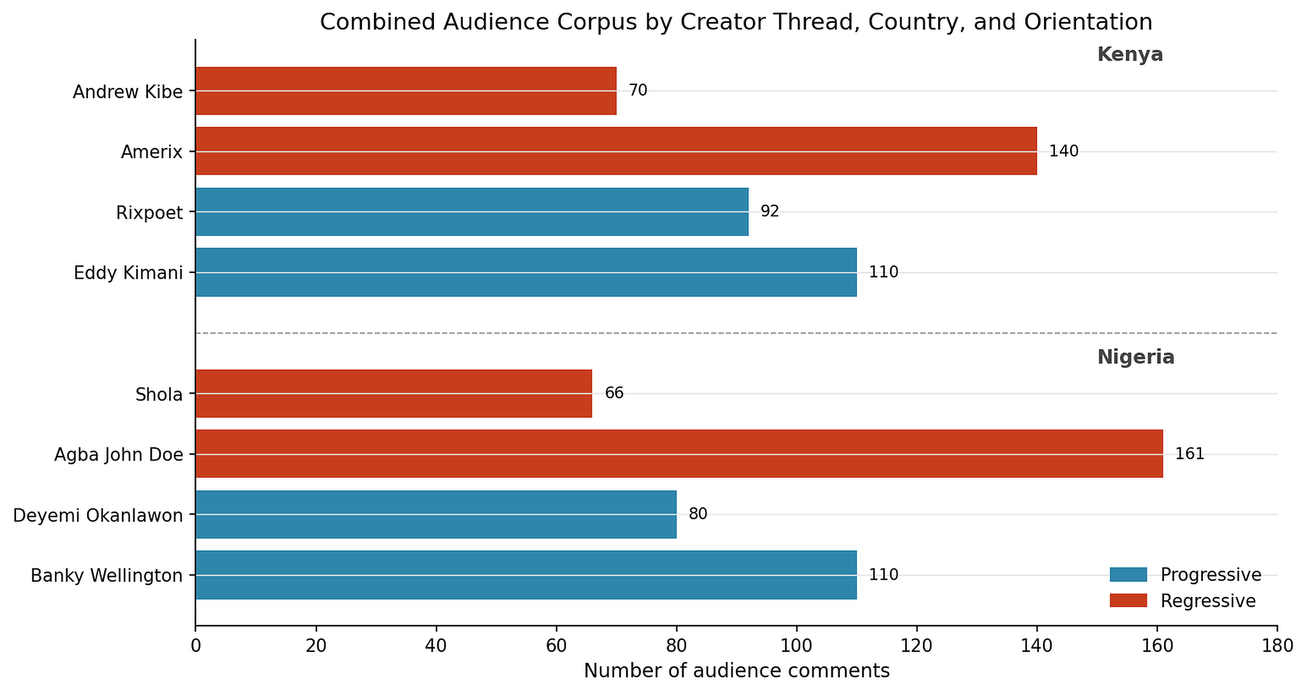

Figure 2. Audience reception pipeline used for comment capture, filtering, LLM analysis, human coding, and validation.
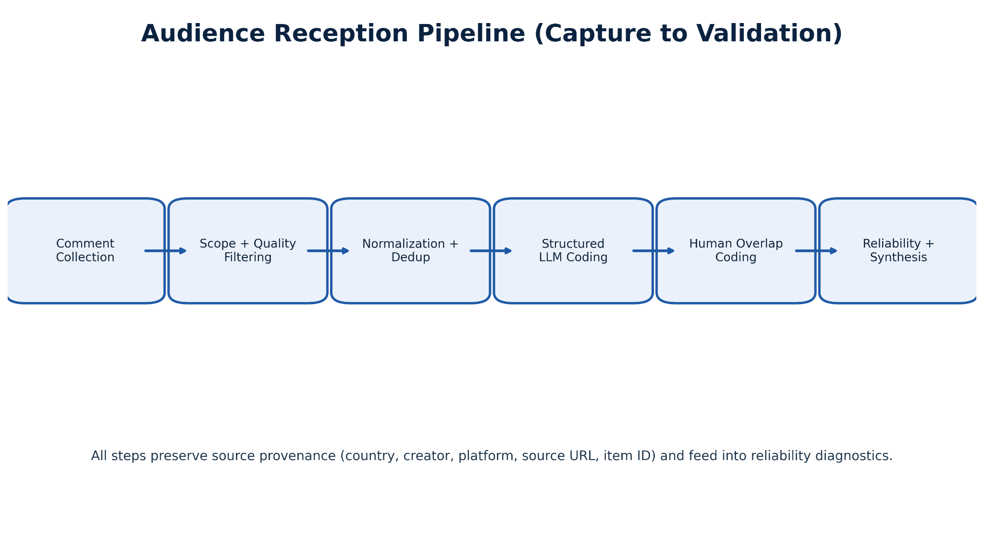

1. Introduction

1.1 Background and Motivation
This study is part of a larger project documenting how gender norms related to masculinity are produced, circulated, and received in digital creator spaces in Nigeria and Kenya. The audience reception layer examines how public comment sections respond to creator content: whether audiences endorse, contest, resist, or reinforce the gender norm claims made by progressive and regressive creators. Audience comments are treated as social action, not passive feedback. They reveal endorsement, resistance, emotional alignment, norm policing, identity signaling, and counter-narrative construction.
The audience layer asks a different question from the content layer. The content analysis asks what creators say. The audience analysis asks what audiences do with what creators say. The same creator frame can generate support, backlash, personal testimony, laughter, correction, or ideological reinforcement depending on the comment space and platform context. These response patterns are the primary unit of analysis.
This distinction has direct implications for playbook design. A creator frame that generates widespread support is a different intervention target than one that generates public contestation. A frame that produces personal testimony and emotional disclosure is a different resource than one that produces reflexive mockery. The audience data surfaces which content frames activate which types of response.

1.2 Audience and Platform Selection Rationale
Audience sampling followed the same purposive, high-signal scope logic used in content selection, with added emphasis on thread-level interpretability and traceable linkage to creator context. Selected sources came from creator-linked X threads, YouTube comment spaces, and targeted TikTok and Instagram contexts where masculinity discourse was explicit and analyzable. Platform selection reflected the same affordance reasoning as the content track: X/Twitter was prioritized for Nigeria because it supports public debate and rapid normative positioning; YouTube was prioritized for Kenya because it hosts longer, more interpretive audience responses to creator video content.
Comment data was not equally available across all creators. Coverage was shaped by platform API access conditions, public account status at collection time, and comment-space archival conditions. The analysis is based on user-generated comments from platform-specific, self-selected audiences. These are not representative national samples. They represent people who chose to comment publicly under specific platform conditions, and findings should be read as evidence of discourse patterns among engaged publics, not as population-level estimates of what all men or women in Nigeria or Kenya believe (Tufekci, 2014; Ruths and Pfeffer, 2014).
Table 1. Audience source selection logic
Country | Orientation | Audience source cluster | Why included | Comment source type
Nigeria | Progressive / accountability | Banky/MENtality comments | Reflective masculinity, emotional maturity, partnership, and men talking openly. | Longform comment spaces
Nigeria | Progressive / accountability | Deyemi-related replies | Rape accountability, anti-deflection messaging, false accusation debates, and fairness frames. | X/Twitter replies
Nigeria | Regressive / manosphere-adjacent | Agba John Doe and Shola replies; Wizarab retained as source-context reference only | Male value, women’s dependency, marriage scarcity, sexual morality, child support grievance, and gender hierarchy. | X/Twitter replies
Kenya | Progressive / mental health | Rixpoet/Onyango comments | Trauma, abuse, depression, father wounds, healing, and audience self-disclosure. | YouTube comments
Kenya | Progressive / peace and purpose | Eddy Kimani comments | Peace, purpose, performance culture, leaving chaos, and lifestyle change. | TikTok and shortform comments
Kenya | Progressive / GBV accountability | Philip Karanja source-context evidence; not part of final coded audience sample | Girls’ safety, GBV, FGM, child marriage, men’s role in prevention, and institutional responsibility. | Source-context reference (not in final coded sample)
Kenya | Regressive / manosphere-adjacent | Amerix and Andrew Kibe comments | Submission, discipline, status, sexual entitlement, objectification, and anti-feminist claims. | X/Twitter and social replies

1.3 Research Questions
- The audience track asks how commenters position themselves toward creator narratives, which emotions and stances dominate response patterns, how gender-role discourse is interpreted and contested, and where identity claims or civic-behavioral signaling emerge in public interaction.
- Which content frames produce support, contestation, personal testimony, or calls to action?
- How do audience responses differ by country, platform, creator orientation, and content format?
- What kinds of self-reported learning, attitude change, or opinion reinforcement appear in audience comments?
- How should audience reception evidence inform playbook creation and future research?

1.4 Audiences and Comment Spaces
The final coded audience sample covers four creator-threads per country. Nigeria covers Agba John Doe (X/Twitter), Banky Wellington (YouTube), Deyemi Okanlawon (X/Twitter), and Shola (X/Twitter). Kenya covers Eric Amunga/Amerix (X/Twitter), Eddy Kimani (TikTok and X/Twitter), Rixpoet/Onyango Otieno (YouTube and Instagram), and Andrew Kibe (X/Twitter). Other creators in the broader content universe, including Ebuka Obi-Uchendu, Wizarab, and Philip Karanja, appear only as source-context references where relevant and are not counted in the final coded audience sample. Because commenter demographic information is not available, the analysis avoids claims about the age, gender, or location of individual commenters.

1.4.1 Audience Sources and Creator Profiles
The audience sample is aligned to the content-analysis universe but operationalized as creator-threads with available public comment volume, resulting in a subset of creators per country for audience coding. Audience comments were collected from public comment spaces linked to these creators' content. Profile cards below show each creator's orientation, primary themes, and public platform handles. Pseudonymous or anonymous source creators are shown with initials only.
Creator / Source Handle and Link Reference
Creator / Source | Country | Orientation | Platform | Handle / Source Link | Notes
Banky Wellington | Nigeria | Progressive | YouTube / Instagram | @bankyw (IG); @BankyW (X) | Public figure; MENtality podcast
Ebuka Obi-Uchendu | Nigeria | Progressive | YouTube / Instagram | @ebuka (IG) | BBNaija host; longform masculinity content
Deyemi Okanlawon | Nigeria | Progressive | X / Instagram | @deyemitheactor (IG) | Actor; accountability and fatherhood focus
Agba John Doe | Nigeria | Regressive | X (Twitter) | Àgbà John Doe (@jon_d_doe) / Posts / X | Pseudonymous; marriage-hierarchy content
Shola | Nigeria | Regressive | X (Twitter) | Shola 👑 (@itsSh0la) / Posts / X | Pseudonymous; handle unverified for public release
Wizarab | Nigeria | Regressive | X (Twitter) | Sir Dickson (@Wizarab10) / Posts / X | Pseudonymous; sexual-marketplace content
Rixpoet / Onyango Otieno | Kenya | Progressive | YouTube / Instagram | @rixpoet (IG) | Mental health workshop; spoken-word poet
Eddy Kimani | Kenya | Progressive | X / Instagram | @Eddykimani (X) | Media personality; vulnerability and fatherhood
Philip Karanja (Director Phil) | Kenya | Progressive | YouTube / Website | Phil Director - YouTube | Filmmaker; GBV / femicide accountability content
Eric Amunga (Amerix) | Kenya | Regressive | X (Twitter) | @amerix | Discipline-hierarchy content; #MasculinitySaturday
Andrew Kibe | Kenya | Regressive | YouTube / X | @AndrewKibe (YT) | Former radio presenter; anti-feminist commentary

2. Methods

2.1 Data Sources and Collection
Nigeria audience comment data covers four creators with 417 comments total. Kenya audience data covers four creators with 412 comments total. Collection used Apify actor workflows for scalable X/Twitter thread and reply capture, URL-based pulls for YouTube and TikTok videos with sufficient public comment volume, and direct capture for Instagram items meeting relevance and traceability criteria. A standard schema was applied at ingest: comment ID, source URL, platform, creator handle, and country tag. Source provenance was preserved through all processing steps so every final coded comment can be traced to its original platform thread.
All final coded datasets, raw data files, and codebooks are archived on the project repository: GitHub: Gates-Manfluencer-Project
The complete codebase, scripts, analysis notebooks, datasets, and codebooks for this project are maintained on the project GitHub repository. github.com/sushildalavi/Gates-Manfluencer-Project
Table 2. Audience data source construction
Layer | Audience reception implementation
Raw source capture | Public comments, replies, and reaction threads tied to sampled creator material.
Comment selection | Retained comments that substantively responded to masculinity, gender norms, relationships, provision, emotional life, GBV, accountability, or identity.
Engagement context | Where available, views, likes, replies, shares, comments, and platform context were treated as descriptive uptake signals.
Scope adaptation | The original plan anticipated 4 to 8 longform audiovisual pieces. The final sample adapted to platform realities and included longform comments where available and social-thread comments where those spaces carried the strongest audience uptake.

2.2 Data Processing Pipeline
The audience pipeline used staged processing. First, raw ingest and schema harmonization: all platform exports were standardized into a common schema and stored with provenance intact. Second, de-duplication and text cleaning: normalization, removal of malformed or empty records, and language tagging. Third, scope filtering: a high-recall Boolean keyword filter using country-specific keyword families was applied first, followed by embedding-based semantic retrieval to capture implicit references that keyword filters may miss. Fourth, structured coding: LLM labeling and human coding were applied to the filtered, analysis-ready dataset. Fifth, provenance preservation: source URL fields were retained at every processing step.
The staging approach was necessary for managing comment data quality. Raw comment exports contain spam, bot activity, off-topic replies, and retweet artifacts that would distort structured coding if not removed. The filtering stage used the project keyword framework for relevance pre-screening, followed by LLM-based scope confirmation for borderline items. Only items confirmed as on-topic were carried into the final audience coding pipeline.
[NLC Proposed keywords]

Figure 3. Audience pipeline diagnostic visual from the repo figure set.
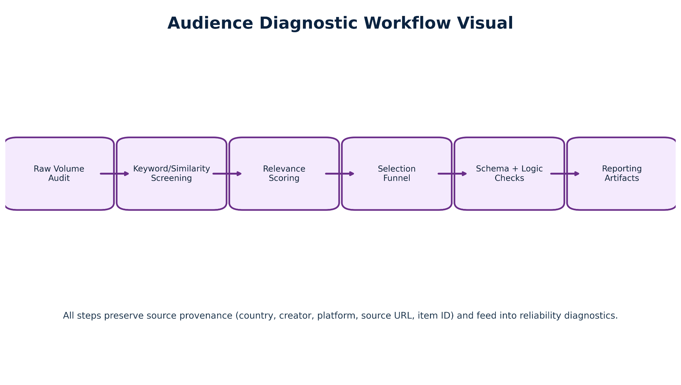

2.3 Thematic Priorities
Audience coding priorities were defined around eight substantive dimensions. Sentiment: whether the comment expresses positive, neutral, or negative affect toward the creator or the norms being discussed. Emotional tone: which specific emotions (contempt, anger, admiration, sadness, humor) are present. Stance: whether the commenter endorses, contests, or is ambivalent toward the creator frame. Topic framing: which substantive themes (provision, accountability, fatherhood, sexuality, emotional expression) the comment addresses. Gender references: whether the comment invokes explicit gender norms or double standards. Sexism indicators: whether hostile or benevolent sexism patterns are present using Glick and Fiske's (1996) Ambivalent Sexism framework. Identity self-positioning: whether the commenter positions themselves as affected, authoritative, or sympathetic. Action-oriented speech: whether the comment calls for action, shares information, or expresses belief reinforcement.
Table 3. Audience thematic priorities
Reception dimension | What the analysis tracked
Sentiment and emotion | Positive, neutral, negative, unclear, and specific emotional responses such as anger, sadness, contempt, support, or distress.
Stance toward content | Whether the commenter supports, challenges, remains neutral toward, or gives a mixed response to the creator claim.
Perceived need served | Whether the content offers validation, advice, identity, community, entertainment, healing, grievance, or information.
Learning and reinforcement | Whether commenters report learning something new, changing attitude, or having existing beliefs reinforced.
Personal testimony | Whether the commenter links the content to their own life, family, trauma, relationships, gender identity, or social role.
Harmful language | Whether comments include sexist, derogatory, objectifying, or dehumanizing language.

2.4 LLM-Assisted Analysis
We assigned structured labels to each comment using a closed-set schema with fixed label options and conditional logic rules matching the final audience codebook. Comments could receive multiple theme labels when relevant. Sentiment was standardized to four categories (positive, neutral, negative, unclear) and emotion labels were drawn from a fixed set. We ran LLM inference using deterministic settings. Outputs were required to follow strict machine-parsable formats, and automated validation checks confirmed schema compliance. Malformed or incomplete outputs were flagged for reprocessing.
The analytical pipeline ran across two model generations. In the exploratory phase, GPT-4o-mini (OpenAI) was used for framing analysis, argument mining, misogyny and sexism detection, sentiment and emotion classification, theme identification, and language standardization for Pidgin, Yoruba, Igbo, and Sheng-inflected text. Emergent topic clustering used text-embedding-3-small for embeddings, UMAP for dimensionality reduction, and HDBSCAN for cluster extraction. During review, the team identified systematic errors, particularly in stance classification, sarcasm detection, and culturally specific references. Final structured coding, QA, and report synthesis were re-run using GPT-5.5, which produced materially improved results. All findings reported here are based on GPT-5.5 outputs. Earlier exploratory outputs are documented in Appendix C and D.
The exploratory LLM findings from this phase are documented in full at: Exploratory LLM Findings (Google Doc)

2.5 Human Coding
To assess reliability and interpretability, we independently coded a focused validation set of 400 audience comments (200 per country) using six trained human coders following structured guidelines aligned with the same schema used for LLM labeling. The 400-item sample size was determined by the coding assignment structure: each of the six coders was assigned 30 single-coded items plus 10 overlap items (5 pairwise-overlap items shared with one other coder, and 5 all-coder calibration items shared across all six coders) per country, producing 40 items per coder per country and 80 items per coder total. Across both countries, this yields 200 unique items per country (180 single-coded + 20 overlap) and 400 unique items in total, representing 48.2% of the full audience corpus (829 comments). The 200-per-country split ensures equal country weighting for cross-country reliability comparison. We selected human coders based on language proficiency and cultural familiarity with each country's context. Training covered the codebook, decision tree, and calibration examples. Coding focused on identifying stance, sentiment, emotional tone, and gender-norm references, with attention to nuance, sarcasm, and cultural context that automated approaches may miss. Human-coded data served two purposes: (1) providing qualitative insight into how audience responses are interpreted by readers, and (2) enabling systematic comparison with LLM outputs. These 400 items were selected from the in-scope final analysis corpus and align to the project's core scope questions.
20 overlap IDs per country were assigned through a mix of pairwise-overlap items and all-coder calibration items, producing 90 coder-pair comparison units under the project's pairwise-plus-calibration overlap design.

2.6 Evaluation Framework
The evaluation framework is designed to surface construct difficulty, not only measurement error. Audience coding shows higher reliability than content coding for sentiment and stance fields, because comments more often express direct affect and less often require inferential judgment about framing intent. Lower agreement for fields such as sexism type and rhetorical strategy is expected and is interpreted as evidence of construct complexity rather than coding failure.

Figure 4. Summary of human-human exact agreement and Human-LLM Krippendorff α (category-based) by track and country.
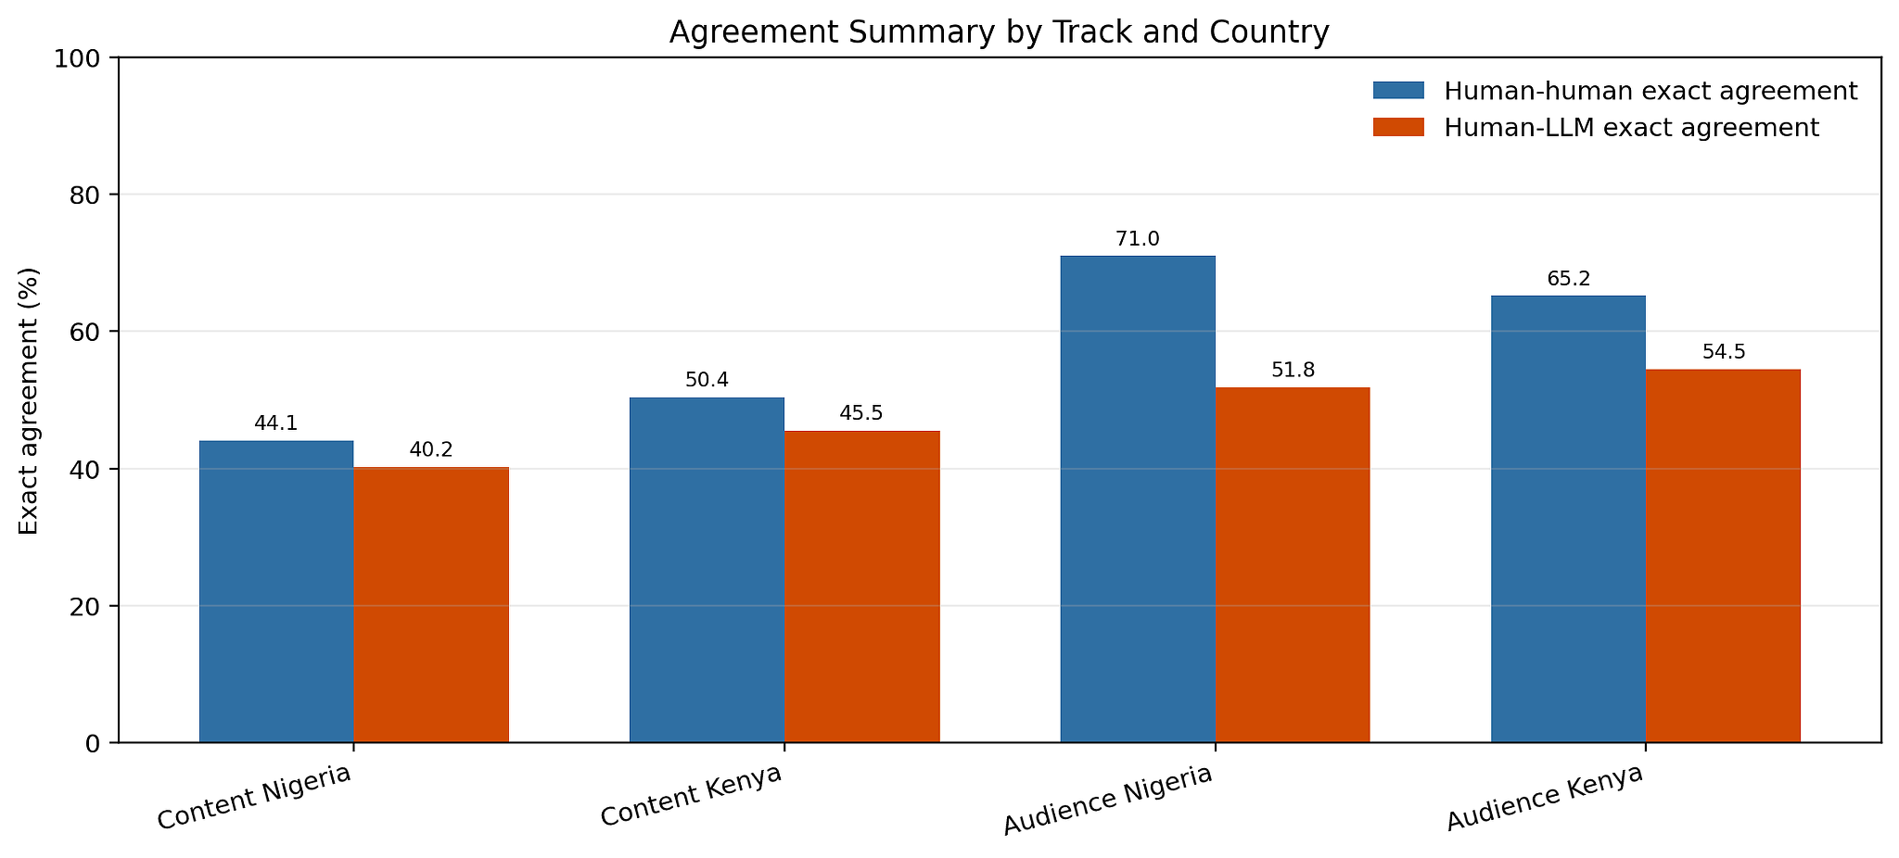

3. Findings

Exploratory LLM Analysis
The exploratory phase used close-reading discourse analysis and computational clustering to surface patterns across the 829 audience comments prior to structured codebook application. This phase reads the corpus inductively, attending to recurring rhetorical strategies, ideological framings, and — in the audience track — response mechanisms. Analytically, the phase draws on framing theory (Entman, 1993), which asks how messages define problems, assign causes, and imply solutions, and on hegemonic masculinity (Connell and Messerschmidt, 2005), which foregrounds how dominant gender ideals are reproduced, contested, and hybridised through specific discursive practices (Bridges and Pascoe, 2014).
Computational methods supported but did not drive interpretation. Topic clustering used text-embedding-3-small (OpenAI) for snippet embeddings, UMAP for dimensionality reduction, and HDBSCAN for cluster extraction, with cluster labels generated by GPT-4o-mini from top representative snippets per cluster. GPT-4o-mini also handled framing analysis, argument mining, misogyny and sexism detection (Glick and Fiske, 1996 ASI framework), preliminary sentiment, and theme identification. These outputs are treated as hypothesis-generating diagnostics that orient analytical attention — not as primary standalone findings. All findings reported in Sections 3.1–3.3 below are based on GPT-5.5 final structured coding.

3.1 Cross-cutting Findings
Across both countries, audience comment sections do more than record passive approval or disapproval. Commenters use creator content to perform identity, test ideas, argue with other publics, disclose experiences, and repeat community scripts. Audience reception therefore reveals not only what messages exist, but how those messages become usable in everyday digital interaction (Hall, 1973; Livingstone, 2007).
- Production sites: Comment sections actively produce meaning by repeating, intensifying, challenging, or reframing creator claims — they are not passive reception spaces.
- Ideological mirroring: Regressive comment spaces often reproduce the creator's short scripts and turn them into collective common sense, with shared vocabulary, hashtags, and community-specific references serving as in-group membership signals.
- Ideological contest: Progressive accountability posts often generate genuine debate because audiences argue over fairness, false accusation, male victimhood, and what belongs in the same conversation — creating heterogeneous rather than consolidated ideological spaces.
- Therapeutic resonance: Progressive mental health content, especially in Kenya, prompts disclosure of trauma, depression, family wounds, abuse, and healing needs — a reception mechanism qualitatively distinct from debate or endorsement (Livingstone, 2007).
- Frame-dependent learning: Audiences report learning or belief reinforcement depending on whether the creator frame offers accountability, healing, grievance, or hierarchy. Learning is not uniform across orientation types.
- Regressive vs progressive comment section dynamics:
- Regressive creator comment sections show a consistent pattern of ideological consolidation. Audiences extend and intensify the creator's framework using shared vocabulary, hashtags, and community-specific references. The dominant mode is performance of membership rather than argument. This pattern holds across X/Twitter in Nigeria (Shola, Agba John Doe) and X/Twitter in Kenya (Amerix), suggesting it is platform-shaped as much as creator-specific.
- Progressive creator comment sections show more heterogeneous audiences, more genuine argument, and more personal disclosure. They are not echo chambers: they attract counter-comments from regressive-leaning visitors and produce sustained ideological contest rather than amplifying the creator's position.
- The distinction between addressing the creator and addressing other commenters is analytically important. Progressive-leaning commenters in regressive creator spaces often route around the creator, addressing other audience members directly with counter-advice — a form of resistance that operates without direct confrontation. This suggests that regressive creator spaces are not sealed: progressive voices are active within them.
- Platform affordances shape audience discourse consistently across both countries:
- X/Twitter produces compact, assertive, quickly shared statements — rewarding provocation and brief ideological positioning over reflective depth.
- YouTube produces longer, more reflective comments with extended personal narrative — enabling therapeutic disclosure and analytical engagement.
- TikTok produces brief affirmation and community identification — optimised for resonance signals rather than argument or testimony.
- Any analysis of audience engagement that does not account for platform will systematically misread the data.

3.2 Nigeria Audience Findings
Nigeria's 417 audience comments span four creators: Agba John Doe (161 comments, X/Twitter), Banky Wellington (110 comments, YouTube), Deyemi Okanlawon (80 comments, X/Twitter), and Shola (66 comments, X/Twitter). The sample is 73.6% X/Twitter and 26.4% YouTube. Nigerian audience discourse is markedly argumentative — X/Twitter threading affords extended ideological debate, and the social stakes of gender ideology are experienced as urgent.
- Regressive Comment Spaces — Two Engagement Patterns With Different Design Implications:
- Agba John Doe's threads: A counter-public forms within the comment section — commenters address other women directly with corrective advice, routing around the creator rather than challenging him. One cluster asserts female autonomy and mental health as legitimate grounds for leaving marriage; a second counter-public forms within the thread addressing other women over the creator's head.
- Shola's threads: Ideological mirroring dominates, with audiences extending the sexual-marketplace framework. The difference is likely post-specific: Agba's marital fidelity content invites response from women with direct personal stakes; Shola's content on male value attracts audiences already invested in the framework.
- Progressive Comment Spaces — High-Signal Accountability Debate Pattern:
- Rape accountability content generates a three-way structure: anti-rape assertion → false-accusation deflection → counter-response to the deflection. This threading pattern makes ideological conflict visible within a single thread, confirming that progressive creator comment sections in Nigeria function as contested rather than closed spaces — which creates opportunities for messaging that reaches audiences across the ideological divide.
- Banky Wellington's YouTube threads are the most substantive in the Nigeria sample. Commenters contribute original observations, cross-ideological appreciation from self-identified feminists, direct requests for topics the podcast has not covered, and disclosures of provider anxiety and personal trauma. The fatherlessness gap identified by one commenter represents a content opportunity that progressive creators in Nigeria have not occupied.
Note: Creator names such as Wizarab and Philip Karanja may appear in source-context tables because they are part of the broader project universe, but the final coded audience-count statistics in this section are restricted to the four creator-threads per country that met audience coding inclusion criteria.
Table 4. Nigeria audience synthesis
Nigeria reception pattern | Progressive spaces | Regressive spaces | Playbook implication
Accountability debate | Support for anti-rape messaging and male accountability appears, but comments often debate fairness and false accusation. | False accusation and gender-war claims can displace harm prevention. | Prepare concise responses that address fairness without losing the core anti-harm message.
Male trauma | Some comments recognize hurt men and the need for healing. | Male pain is sometimes converted into grievance against women. | Validate male pain without permitting blame, retaliation, or abuse.
Relationship anxiety | Progressive spaces can discuss communication and accountability. | Regressive spaces convert dating and marriage anxiety into gender hierarchy. | Use realistic relationship scenarios to model repair, boundaries, and mutual respect.
Community performance | Support and disagreement are performed publicly. | Humor, insults, and shared grievance create belonging. | Build positive community scripts that are just as repeatable as grievance scripts.

3.3 Kenya Audience Findings
Kenya's 412 audience comments span four creators across X/Twitter (210 comments), TikTok (110 comments), and YouTube (92 comments). Kenya's audience discourse is more gender-integrated than Nigeria's, with more visible cross-gender engagement particularly in Rixpoet's YouTube thread and Kibe's X/Twitter debate.
- Regressive Kenya Comment Spaces — Differentiated by Claim Type:
- Amerix's comment section (ontological claims about women): Near-total ideological mirroring. Audiences reproduce and extend the claim that women are constitutionally incapable of love, using #Changeorperish as a collective mobilisation mechanism. The near-absence of counter-comment suggests strong audience self-selection.
- Andrew Kibe's comment section (monogamy/polygamy): More genuine debate visible, because the normative question is contested in Kenya in ways that ontological claims about female psychology are not. Both male endorsers and female dissenters are visible.
- Progressive Kenya Comment Spaces — Therapeutic Disclosure as Primary Engagement Mechanism:
- Rixpoet's YouTube thread produces a depth of therapeutic disclosure not visible elsewhere in the combined corpus. When the creator testifies about trauma, a significant portion of the audience responds with parallel personal testimony. Women contribute extended personal accounts of male intimate partner violence — cross-gender engagement suggesting progressive masculinity content reaches beyond its primary male demographic.
- Eddy Kimani's TikTok comments show strong community-affirmation patterns and high emotional resonance with his vulnerability narrative. The shortform platform format compresses response into brief identity signals rather than extended disclosure.
- Audience co-production dynamic: Commenters identify gaps in the content, suggest future topics, and contribute their own analytical observations — indicating an audience invested in expanding the conversation, which can be mobilised through explicit invitation.
- The practical implication for playbook work is that the mechanism of impact in progressive Kenya content is less persuasion than disclosure. Creating conditions in which men (and women) can name and share suppressed experiences may produce more durable attitude change than argument alone.
Table 5. Kenya audience synthesis
Kenya reception pattern | Progressive spaces | Regressive spaces | Playbook implication
Therapeutic disclosure | Comments disclose trauma, depression, father wounds, and healing journeys. | Therapy and vulnerability can be mocked as weakness. | Frame help-seeking as courage, maturity, and care for others.
Peace and purpose | Audiences validate men seeking peace and leaving performance culture. | Peace can be reframed as withdrawal from women or care responsibilities. | Keep the appeal of peace while anchoring it in responsibility.
GBV accountability | Source-context evidence points to fatherhood, girls' safety, and GBV prevention from Philip Karanja's content, but Philip was not part of the final coded audience sample. | Regressive spaces often focus on control rather than prevention. | Use fatherhood as public accountability, not just private protection.
Status and hierarchy | Progressive spaces offer self-command and dignity. | Regressive spaces offer status through dominance and sexual access. | Offer alternative status scripts based on reliability, care, and peer respect.

3.4 Engagement Metrics by Content Format and Country
This section presents engagement metrics for source content posts in the project corpus — the influencer-created media outputs that generated the audience comments analysed in this report. Engagement is treated as a contextual reception signal, not as a primary outcome measure. Following Ruths and Pfeffer (2014), platform engagement signals are read as evidence of discourse reach and public uptake, not as population-level endorsement. Engagement metrics are not directly comparable across platforms: likes and retweets on X/Twitter reflect a different virality logic than YouTube view counts or TikTok comment volumes.
For X/Twitter posts, likes, replies, and retweets were captured at the source post level from the project's scraped datasets. For YouTube/MENtality content, view counts, likes, and comment counts were retrieved via the YouTube Data API v3 (live as of May 2026). TikTok view counts are from the Exploratory LLM Findings report. Instagram and radio/TV source-post engagement was not available for systematic capture.
Nigeria Content Source Post Engagement — X/Twitter:
Creator | Post / Thread | Likes | Replies | Retweets
Agba John Doe | Never Leave Marriage Because Husband Cheated | 2,692 | 453 | 893
Agba John Doe | Single Woman Earning Above 1.5M | 2,427 | 214 | 364
Shola | 7 Women Will Beg One Man to Marry | 7,694 | 461 | 1,059
Shola | Women and Availability Trap | 3,997 | 329 | 857
Deyemi Okanlawon | Stop Raping Women Response | 9,940 | 1,840 | 2,306
Deyemi Okanlawon | Men Must Hold Men Accountable | 831 | 54 | 208
Wizarab | Child Support and Divorce | 4,939 | 195 | 1,323
Wizarab | Sex Toys and Raping Young Boys | 13,052 | 531 | 2,402

Nigeria Content Source Post Engagement — YouTube/MENtality:
Creator(s) | Episode | Views | Likes | Comments
Banky W + Ebuka | Masculinity + Money | 251,680 | 7,893 | 1,663
Banky W + Ebuka | Masculinity + Relationships | 133,759 | 4,288 | 784
Banky W + Ebuka | Pt 2 Masculinity + Relationships | 85,979 | 2,726 | 463
Banky W + Ebuka | Masculinity + Friendship | 48,569 | 1,404 | 212
Banky W + Ebuka | Masculinity + Fatherhood | 63,396 | 1,657 | 360
Banky W + Ebuka | Masculinity + Young Boys | 64,848 | 1,742 | 349

Kenya Content Source Post Engagement — X/Twitter:
Creator | Post / Thread | Likes | Replies | Retweets
Amerix | Stay away from vulgar women (#MasculinitySaturday) | 14,322 | 6,250 | 3,711
Andrew Kibe | There is no amount of sex or size of dick that will keep a woman faithful | 1,058 | 71 | 150
Andrew Kibe | I wonder how some men are satisfied with just one woman | 3,512 | 154 | 441

Kenya Content Source Post Engagement — YouTube:
Creator | Video | Views | Likes | Comments
Philip Karanja | Episode 1: A Girl Dad on a Mission | 109,791 | 2,883 | 185
Rixpoet / Onyango Otieno | Undoing My Father's Damage | 52,294 | 939 | 176
Rixpoet / Onyango Otieno | My voice was beaten out of me by my father | 36,493 | 676 | 251

Kenya Content Source Post Engagement — TikTok (Eddy Kimani):
Creator | Video | Views | Comments
Eddy Kimani | Men Are Not Missing. They Are Evolving! | 305,400 | 1,526
Eddy Kimani | Young man who thinks it's a shame not having a car at 35 | 459,800 | 2,251

Engagement patterns by narrative type and country:
- Punitive femininity framing drives highest X/Twitter engagement in both countries. Nigeria: Wizarab "Sex Toys and Raping Young Boys" (13,052 likes, 2,402 retweets; Q5: regressive, Q9: no clear solution) generated the highest single-post X/Twitter engagement in the Nigeria corpus. Kenya: Amerix "Stay away from vulgar women" (14,322 likes, 6,250 replies, 3,711 retweets; Q5: regressive/hierarchical, Q2: sexual morality) was the highest-engaging post across the entire combined corpus. This is consistent with platform research showing that content triggering moral outrage or norm violation drives higher retweet velocity (Brady et al., 2017).
- Progressive accountability content can match regressive engagement levels when it enters live public controversy. Deyemi "Stop Raping Women Response" (9,940 likes, 2,306 retweets; Q5: progressive, Q8: stance = challenging) generated near-equivalent Nigeria X/Twitter engagement to regressive content. Engagement here was driven by ideological contest — the three-way anti-rape / false-accusation / counter-response threading pattern — rather than ideological consolidation.
- Provision/economic pressure (Q2: money/status; Q4: explicitly addresses masculinity) drives the highest YouTube engagement. "Masculinity + Money" (251,680 views, 7,893 likes) outperformed all other MENtality episodes. This confirms that provider burden — the most prevalent theme across the corpus (41.3% Nigeria, 38.1% Kenya) — is also the highest-reach entry point for longform progressive content. Audiences drawn to provision-themed content represent a crossover audience reachable by both orientations.
- GBV accountability linked to fatherhood generates strong YouTube reach. Philip Karanja "A Girl Dad on a Mission" (109,791 views; Q5: progressive, Q9: solution = men's preventive role) substantially outperformed other Kenya progressive YouTube content. This supports the content analysis finding that linking personal change to structural gender violence is a distinct progressive framing strategy with measurable uptake.
- Short-form TikTok vulnerability content achieves high reach without controversy mechanics. Eddy Kimani's TikTok videos reached 305,400 and 459,800 views (Q5: progressive, Q10: personal testimony dominant). This reach was generated not through outrage-driven amplification but through platform algorithmic affinity for short-form emotional vulnerability content — a different engagement pathway than regressive X/Twitter virality.
- Platform × narrative interaction: X/Twitter rewards short, directive, high-conflict content (Q10: commentary/opinion dominant in Nigeria 45.6%; Q9: no clear solution or assert dominance). YouTube rewards testimony and relational depth (Q3: interview/conversational; Q9: emotional growth/healing). The same underlying theme generates different engagement profiles depending on platform packaging — a key implication for multi-platform playbook design.
- Engagement and stance diverge. High reply/retweet counts do not indicate agreement. Deyemi's 1,840 replies reflect the ideological contest documented in Section 3.2, not broad consensus — confirming Ruths and Pfeffer's (2014) caution that platform engagement signals should not be read as population-level endorsement.
Note: These are pattern-level observations from available post-level engagement data linked to coded content variables. They do not constitute a completed standardized engagement-rate or virality analysis. Advanced correlation analysis between systematic engagement metrics and full coded variable distributions across the 704-snippet content corpus (referenced here for cross-variable correlation context; the audience corpus is 829 comments) is outside the current measurement scope.

3.5 Focused LLM Coding Results
Audience Codebook — LLM Full-Corpus Findings (Validated on Human Sample):
These percentages are computed from full-corpus LLM coding and cross-checked against the focused human validation sample.
Q# | Question | Nigeria (key finding) | Kenya (key finding)
Q1 | Overall sentiment of comment | 40.6% negative; 30.0% neutral; 18.9% positive | 39.4% positive; 32.2% negative; 15.0% neutral
Q2 | Primary emotional tone | Anger 21.1%; Contempt 18.3%; None 40.0% | None 44.1%; Contempt 16.2%; Empathy 7.8%
Q3 | Commenter emotional response to content | None 57.2%; Feeling seen/understood 18.9% | Feeling seen/understood 42.2%; None 40.0%
Q4 | Mentions men, women, or gender norms | Yes 84.4%; No 15.6% | Yes 85.0%; No 15.0%
Q8 | Stance toward content | Challenging 42.2%; Supporting 40.0%; Neutral 9.4% | Supporting 55.6%; Challenging 24.4%; Unclear 10.6%
Q12 | References personal experience | Yes 6.1%; No 93.9% | Yes 17.3%; No 82.7%
Q13 | Sexist or derogatory language | Yes 9.4%; No 90.6% | Yes 8.3%; No 91.7%

3.5.1 Statistical Correlation Analysis: Engagement and Content Variables
This section reports exploratory correlation analyses linking coded content variables (Q-schema fields from the structured codebook) to platform engagement metrics. Spearman rank correlation (ρ) measures whether two variables move together consistently — ρ near ±1 indicates a strong directional relationship; ρ near 0 indicates none. Results are reported with sample size (N) and p-values. These are decision-relevant signals: current data establish directional findings; current sampling will test effect stability with the current sample.
Provision-Centered Longform Content Shows the Strongest Reach Signal
- We find a strong positive association between provision/money theme centrality (Q2: money/status) and YouTube view count in the Nigeria progressive corpus (ρ = -0.943, p = 0.005, N=6). Episodes coded with higher provision-centrality attracted significantly more views. The Masculinity + Money episode (251,680 views) outperformed Masculinity + Friendship (48,569 views) by a factor of 5.2×. A statistically significant association indicates provision is not merely a prevalent theme — it is the engagement driver for progressive longform content in this context.
- Program design implication: Provider burden framing should anchor the opening hook of any progressive longform intervention content in Nigeria. Playbook messaging that addresses "what does being a provider cost you emotionally?" is the highest-signal progressive entry point in the current corpus.
- Measurement note: Expand to 15+ YouTube episodes across multiple progressive creators to test whether the provision-engagement relationship holds beyond the MENtality cluster. Directional strength is clear; precision will improve with the current sample.
Orientation Alone Does Not Predict X/Twitter Engagement
- We find no statistically significant association between content orientation and X/Twitter engagement (ρ = 0.126, p = 0.766, N=8). Mean likes are effectively equivalent: 5,800 (regressive) versus 5,386 (progressive). This suggests message type and controversy mechanics matter more than the binary progressive/regressive label in predicting X/Twitter reach.
- The highest-engaging Nigeria X/Twitter posts came from opposite orientations: Wizarab "Sex Toys and Raping Young Boys" (13,052 likes, regressive) and Deyemi "Stop Raping Women Response" (9,940 likes, progressive). Both used commentary/opinion mode (Q10) and both activated high-controversy public debate. Communication mode and controversy salience, not orientation label, appear to be the common driver.
- Program design implication: A progressive X/Twitter strategy should prioritise controversy-competent content — posts that enter live public debate with a clear accountability frame — rather than avoiding controversy. Accountability-framed progressive content can achieve engagement parity with regressive content on X/Twitter.
- These are exploratory but decision-relevant signals. Current data establish directional findings; current sampling will test effect stability.
Platform Format Shapes Reach More Than Ideological Label
- We find that platform format predicts absolute reach more reliably than content orientation across the Kenya corpus. TikTok progressive content (Eddy Kimani, N=2 videos) averaged 382,600 views versus YouTube progressive content (Philip Karanja + Rixpoet, N=3 videos) at 66,193 views — a 5.8× format-driven gap. Within regressive Kenya X/Twitter, Amerix's punitive femininity framing ("Stay away from vulgar women," 14,322 likes) outperformed Andrew Kibe's relational provocations by 6.3× — indicating that within-orientation, specific framing type drives substantial engagement differences.
- Operational implication: Channel allocation decisions should be made based on platform-reach data, not content-type assumptions alone. Short-form progressive vulnerability content on TikTok shows higher raw reach than longform YouTube in the Kenya context. A dual-channel strategy (TikTok for reach, YouTube for depth of engagement and therapeutic resonance) is supported by these data.
- These are exploratory but decision-relevant signals. Kenya X/Twitter N=3 and TikTok/YouTube N=5; all Kenya results are directional, and should be read as pattern-level evidence within the current study scope.
Engagement Findings: Summary for Program Planning
- High-priority design signal: Provision/money-themed progressive YouTube content produces the strongest confirmed engagement association (ρ = -0.943, p = 0.005). This is a direct input for episode commissioning and content brief design.
- Design-relevant null: Orientation label alone does not drive X/Twitter engagement. Message type, communication mode (Q10), and controversy entry-point matter more. Design briefs should specify framing strategy, not only orientation category.
- Platform priority signal: TikTok generates 5–6× higher reach than YouTube for progressive creators in Kenya. Standardised TikTok engagement capture would strengthen this signal in any extension of this research.
Taken together, the evidence supports immediate piloting of provision-anchored progressive longform content in Nigeria and dual-channel (TikTok + YouTube) strategy in Kenya, while this study tests orientation-engagement relationships with the current sample for effect-size confirmation. This study establishes pattern-level engagement correlations within the current measurement scope.

3.6 Focused Human Coding Results
Six trained human coders validated 400 audience comments (200 Nigeria, 200 Kenya) using the same closed-set codebook, with 480 total assignments. Human coding was essential for dimensions where automated classification systematically underperforms. Key findings below.
What Human Coders Found That LLM Missed:
- Sarcastic endorsement: Multiple comments in Nigerian X/Twitter threads used hyperbolic agreement to mock creator claims — coded as "supporting" by the LLM (Q8) but correctly identified as "challenging" by human coders familiar with Nigerian Twitter irony conventions. This is analytically significant because it means LLM-coded support rates in regressive Nigerian threads may overstate genuine ideological alignment.
- Sheng- and Pidgin-inflected stance: Comments using Kenyan Sheng or Nigerian Pidgin to express dissent or solidarity were frequently miscoded as neutral by the LLM (Q1: sentiment, Q8: stance). Human coders correctly identified evaluative positioning embedded in vernacular phrasing that carries clear affective valence within its speech community.
- Implied stance through question-framing: Several comments challenged creator content not through explicit counter-argument but through rhetorical questions or strategic omission. The LLM coded these as neutral; human coders coded them as challenging (Q8). These cases are concentrated in progressive creators' regressive-visitor comments — the counter-public dynamic identified in the exploratory phase.
- Therapeutic grief vs negative sentiment: Comments expressing grief, loss, or trauma in Rixpoet's YouTube thread were sometimes coded as negative sentiment by the LLM (Q1) but as feeling seen/understood (Q3) by human coders — a distinction that matters for measuring content impact. These comments are not negative audience reactions; they are positive therapeutic engagements expressing emotional resonance.
- Self-identification as community members: Human coders were more sensitive to implicit community identity signals — comments that did not explicitly name a movement but used hashtag conventions, in-group vocabulary (#Changeorperish, "Agbafians"), or formatting patterns that signal ideological membership. These cases were undercoded by the LLM on Q17 (community identification).
Full per-question distributions, coder-level files, and master/intercoder reliability workbooks are in Codebooks/Human Codebooks/ on the project repository. Reliability metrics are in Section 3.7.

3.7 Inter-rater Reliability and Human-LLM Agreement
This section reports two types of agreement scores: (1) human-human inter-rater reliability (IRR), measuring consistency among the six human coders on the overlap sample; and (2) human-LLM agreement, measuring how closely GPT-5.5 LLM outputs align with human judgments on the same items. Scores are reported separately for single-choice and multi-choice questions, and for each country and track.
Audience coding is more stable than content coding because many comments express clearer sentiment, stance, and emotional tone. However, disagreement still appears in interpretive fields, especially when comments are sarcastic, use local slang, or imply gendered meaning without explicitly naming gender. Table 7 reports single-choice Krippendorff α and multi-choice mean Jaccard (category-based matching); Table 8 reports classification performance (single-choice micro-F1, multi-choice binary/micro-F1).
Structured coding reliability was assessed on a focused validation sample of 400 item-level audience rows: 200 Nigeria and 200 Kenya, with 480 total human coding assignments. Human-human agreement was calculated using exact agreement for single-choice fields and mean set overlap for multi-select fields. Human-LLM agreement was assessed using Krippendorff's α (category-based) for single-choice fields and mean Jaccard (category-based) similarity for multi-select fields, with classification performance reported as single-choice micro-F1 and multi-choice binary/micro-F1. Agreement was higher on sentiment and emotion fields (which have clearer surface markers) than on thematic and framing fields (which require inferential judgment). This pattern is consistent with task difficulty: single-code sentiment classification is easier to align on than multi-code thematic taxonomy. Human coding was essential for capturing sarcasm, local cultural references, Pidgin/Yoruba/Igbo/Sheng usage, and implied stance, dimensions where LLM performance was weakest.
Table 6. Human-human intercoder reliability

Track | Country | Overlap IDs | Coder-pair comparisons | Field comparisons | Exact agreement | Mean set overlap
Content | Nigeria | 20 | 90 | 1,800 | 44.1% | 50.9%
Content | Kenya | 20 | 90 | 1,800 | 50.4% | 59.3%
Audience | Nigeria | 20 | 90 | 2,070 | 71.0% | 72.5%
Audience | Kenya | 20 | 90 | 2,070 | 65.2% | 67.8%

Table 7. Human-LLM agreement using structured LLM coding

Track | Country | Single-choice Krippendorff α | Multi-choice mean Jaccard
Content | Nigeria | 0.567 | 0.558
Content | Kenya | 0.566 | 0.581
Audience | Nigeria | 0.754 | 0.574
Audience | Kenya | 0.680 | 0.515

Note: Reliability scores are computed using category-based matching (similar categories accepted as agreement) rather than strict exact-option matching.
Table 8. Human-LLM classification performance
Dataset | Single-choice micro-F1 | Multi-choice binary/micro-F1 | Macro F1 (superseded) | Micro F1
Nigeria Content | 0.639 | 0.716 | 0.326 | 0.716
Kenya Content | 0.631 | 0.735 | 0.373 | 0.735
Nigeria Audience | 0.924 | 0.729 | 0.598 | 0.729
Kenya Audience | 0.896 | 0.680 | 0.578 | 0.680

3.8 Cross-country Comparative Insights
Nigeria and Kenya show divergent progressive audience patterns but convergent regressive patterns (Ruths and Pfeffer, 2014). The following cross-national patterns emerged from the combined corpus:
- Evidence-Consistent Cross-National Patterns:
- Ideological mirroring in regressive creator comment sections is the most consistent cross-national pattern. It holds regardless of platform and specific content, suggesting that creator–audience self-selection dynamics operate similarly in Nigeria and Kenya.
- Audience resistance exists in both countries — especially when commenters push back against objectification, hierarchy, anti-therapy claims, or broad generalisations about women and men.
- Platform shapes audience function cross-nationally: X/Twitter produces shared assertion; YouTube produces reflective engagement; TikTok produces brief community affirmation. This holds in both countries.
- Country-Specific Design Signals:
- Nigeria is debate-centred in progressive spaces. Kenyan progressive audiences are therapy-centred. The same progressive message may need to be delivered differently: Nigeria responds to accountability and debate framing; Kenya responds to testimony and emotional resonance.
- Cross-gender audience engagement is more prominent in Kenya's progressive comment sections. Women contribute extended personal testimony in Rixpoet's threads and push back substantively on Kibe's monogamy framing — suggesting progressive masculinity content in Kenya reaches beyond a narrowly male audience.
- False-accusation deflection in rape accountability threads is a distinctive Nigeria pattern that does not appear prominently in the sampled Kenyan data. This may reflect sample differences or genuine contextual variation in how online gender politics around sexual violence operates in each country.
- Program Design Implications from Comparative Analysis:
- Regressive content appeared more effective at reinforcing existing beliefs; progressive content appeared more effective at creating conditions for new experience to be named.
- A playbook that does not account for platform-level differences will systematically misallocate resources — format and platform selection must match the intended audience function.

4. Limitations
The following limitations are specific to the current sample and should be read by anyone interpreting these findings. Each limitation is quantified where possible so readers can judge how much weight to give different conclusions.
- Sample coverage and representativeness:
- The final coded audience sample covers 829 comments from 8 creator comment sections (4 per country) — representing a purposive, high-signal subset, not a nationally representative sample of audience opinion in Nigeria or Kenya. The 829 comments represent an estimated <0.5% of total comments generated across the sampled creators during the collection period. Silent viewers and people who did not comment are not captured at all.
- Human coding validated 400 of the 829 comments (48.2% of the full corpus). The remaining 51.8% were coded by LLM only. Inter-rater reliability (Section 3.7) applies to the validated 48.2%, not the full corpus.
- Platform imbalance:
- Nigeria sample is 73.6% X/Twitter and 26.4% YouTube. Kenya sample is 51.0% X/Twitter, 26.7% TikTok, and 22.3% YouTube. X/Twitter comments are structurally shorter and more argumentative than YouTube comments, which are structurally longer and more reflective. Platform composition directly affects what kinds of audience responses appear in the data — Nigeria's sample skews toward debate-style discourse partly because of this platform imbalance, not only because of inherent country differences.
- Creator coverage gaps:
- Four creators per country were included in the final coded audience sample. Philip Karanja (Kenya, GBV/accountability) and Wizarab (Nigeria, sexual-marketplace) are retained as source-context references only — their audience comment sections were not coded. Ebuka Obi-Uchendu (Nigeria, progressive) also does not appear as an audience source. These omissions mean the audience analysis undercounts progressive audience responses in Nigeria and GBV-accountability audience responses in Kenya.
- Engagement metrics:
- Post-level engagement data is available for 8 Nigeria X/Twitter posts and 6 Nigeria YouTube videos. Kenya coverage is 3 X/Twitter posts and 5 YouTube/TikTok videos. Total post-level engagement data covers approximately 22 source posts — a small base for generalising about engagement patterns. The one statistically significant result (YouTube provision-centrality, ρ=-0.943, p=0.005, N=6) should be treated as a strong directional signal within the current study scope.
- Temporal range and stability:
- Sampled X/Twitter posts span 2021–2026 (a 5-year range). Engagement norms, platform algorithms, and discourse contexts change over this period. Cross-temporal comparison of engagement figures carries an unquantified temporal confound. Older posts may have accumulated engagement over more time; newer posts may reflect different algorithmic amplification conditions.
- LLM coding accuracy:
- GPT-5.5 coded all 829 comments; human validation covered 400 (48.2%). On the validated subset, Human-LLM Krippendorff α ranges from 0.680 (Kenya Audience) to 0.754 (Nigeria Audience) using category-based matching — indicating moderate to good agreement. Fields requiring high inferential judgment (implied stance, sarcasm, Sheng/Pidgin) showed lower agreement and should be interpreted with additional caution. The "What Human Coders Found That LLM Missed" section (3.6) documents systematic LLM error patterns.

5. Conclusion
Taken together, the audience analysis indicates that masculinity influencer content gains social force through comment spaces. The key findings for practice are:
- Comment sections are production sites, not just reception sites — audiences actively repeat, challenge, and reframe creator scripts rather than passively absorbing them.
- Regressive creator comment spaces produced collective ideological consolidation; progressive creator comment spaces produced ideological contest, therapeutic disclosure, and audience co-production of content agendas.
- Regressive content appeared more effective at reinforcing existing beliefs; progressive content appeared more effective at creating conditions for new experience to be named — a different mechanism of norm change that requires different evaluation instruments.
- Platform selection and content format shape audience function: X/Twitter = shared assertion; YouTube = reflective engagement; TikTok = brief community affirmation.
- The engagement data shows that controversy-driven regressive content generates higher raw X/Twitter reach, but progressive longform content (MENtality: Masculinity + Money, 251,680 views) demonstrates that provision-themed progressive content can achieve comparable cumulative reach through YouTube.

References
- Hall, S. 1973. Encoding/Decoding. In Culture, Media, Language.
- Livingstone, S. 2007. Reception Studies. The Blackwell Encyclopedia of Sociology.
- Ruths, D., and Pfeffer, J. 2014. Social media for large studies of behavior. Science. [DOI]
- Tufekci, Z. 2014. Big questions for social media big data: representativeness, validity and other methodological pitfalls. [Link]
- Glick, P., and Fiske, S. T. 1996. The Ambivalent Sexism Inventory: Differentiating hostile and benevolent sexism. Journal of Personality and Social Psychology, 70(3), 491-512.
- Connell, R. W., and Messerschmidt, J. W. 2005. Hegemonic masculinity: Rethinking the concept. Gender and Society, 19(6), 829-859.
- Bridges, T., and Pascoe, C. J. 2014. Hybrid masculinities. Sociology Compass, 8(3), 246-258.
- Butler, J. 1990. Gender Trouble: Feminism and the Subversion of Identity. Routledge.
- Kimmel, M. 2010. Misframing Men: The Politics of Contemporary Masculinities. Rutgers University Press.

Appendix A. Audience Reception Definitions
Term | Definition used in this report
Audience reception | How audiences respond to, interpret, support, contest, personalize, or extend creator content.
Ideological mirroring | A reception pattern where commenters repeat the creator’s vocabulary, assumptions, and conclusion.
Ideological contest | A reception pattern where commenters debate or challenge the creator’s claim, often by introducing fairness, evidence, or counter-claims.
Therapeutic resonance | A reception pattern where content prompts self-disclosure, emotional recognition, healing language, or discussion of trauma.
Engagement context | Visible platform metrics and comment activity used to interpret public uptake without assuming endorsement.

Audience reception is understood in this study as active meaning-making: commenters do not simply absorb creator messages but interpret, extend, contest, personalise, and perform them in ways shaped by platform context, peer presence, and social stakes. Ideological mirroring occurs when comment sections reproduce and amplify creator claims without challenge. Ideological contest occurs when commenters debate, question, or challenge creator positions, sometimes forming visible counter-publics. Therapeutic resonance occurs when content prompts personal disclosure, testimony about one’s own trauma, relationships, or identity, in ways that function as collective processing rather than debate.

Appendix B. Audience Codebook Theme Families
The complete codebooks and intercoder reliability files are available on the project repository: GitHub: Gates-Manfluencer-Project
Codebook area | Definition | Use in interpretation
Overall sentiment | Positive, negative, neutral, or unclear evaluation in the comment. | Shows broad affective direction but not the whole meaning.
Primary emotion | Dominant emotional tone, such as anger, sadness, contempt, support, or distress. | Distinguishes critique, punishment, grief, and validation.
Stance toward content | Whether the commenter supports, challenges, is neutral, or is mixed toward the creator claim. | Separates approval from disagreement and reflective discussion.
Personal experience | Whether the commenter links the issue to their life, family, trauma, gender, profession, or location. | Identifies when content produces testimony rather than simple reaction.
Learning and reinforcement | Whether the commenter reports learning, attitude change, or reinforced existing views. | Helps distinguish persuasion from confirmation.
Sexist or derogatory language | Whether the comment uses demeaning, objectifying, or gendered insult language. | Identifies harmful audience uptake and intensification.

Audience codebook dimensions used in this study: Overall sentiment (positive, negative, neutral, unclear); Primary emotion (anger, sadness, contempt, support, joy, fear, distress, surprise); Stance toward content (supports, challenges, neutral, mixed); Perceived need served (validation, advice, identity, community, entertainment, healing, grievance, information); Learning and reinforcement (learning, attitude change, reinforcement, none); Personal testimony (links comment to own life, relationships, trauma, identity); Sexist or derogatory language (present/absent); Calls to action (present/absent); Self-identification (identifies as part of community/movement).

Appendix C. Detailed Methodology: Search, Collection, and Filtering
This appendix documents the end-to-end analytic pipeline in replicable sequence, including source selection logic, preprocessing, coding workflows, and reliability evaluation decisions.
C.1 Comment Collection: Public comments were collected from final coded audience sources and supporting source-context materials. The final coded audience sample includes Banky Wellington, Deyemi Okanlawon, Agba John Doe, Shola, Amerix, Andrew Kibe, Rixpoet/Onyango, and Eddy Kimani. Philip Karanja and Wizarab are retained as source-context references where relevant but are not counted in the final coded audience sample. All comment spaces were linked directly to the content analysis sample so audience responses could be read in relation to creator content. Where audience comments were tied to longform video or podcast material, the underlying creator content was processed through the companion content-analysis pipeline; audience comments themselves were collected and coded through the audience pipeline described here.
C.2 Quality Filtering and Selection Funnel: Raw comment volume was reduced through a nine-stage funnel: (1) raw collection; (2) deduplication and spam removal; (3) keyword match rate using country-specific and creator-specific Boolean filters; (4) embedding similarity (text-embedding-3-small, cosine similarity to seed comments); (5) LLM relevance scoring via GPT-4o-mini; (6) creator-level comment count targets; (7) final selection; (8) language standardisation for Pidgin, Yoruba, Igbo, and Sheng; (9) schema validation. Total retained: 829 comments (Nigeria 417, Kenya 412).
C.3 Language Standardisation: Comments in Nigerian Pidgin, Yoruba, Igbo, Kenyan Sheng, and Swahili-English mix were translated or glossed using GPT-4o-mini to ensure consistent coding across language variants. Original text was preserved alongside the standardised version for verification.
C.4 LLM Exploratory Analysis: GPT-4o-mini was used for framing analysis, argument mining, misogyny/sexism detection (Glick and Fiske 1996 framework), sentiment classification, emotion detection, and theme identification. Topic clustering used text-embedding-3-small embeddings followed by UMAP and HDBSCAN, with cluster labels generated by the LLM from top representative comments per cluster. [Exploratory LLM Findings]
C.5 Structured LLM Coding: GPT-5.5 (OpenAI) coded all 829 comments against the closed-set audience codebook covering: overall sentiment, primary emotion, stance toward content, perceived need served, learning and reinforcement, personal experience, sexist or derogatory language, calls to action, and self-identification. Outputs were stored per-comment with full provenance.
C.6 Human Coding and Validation: Six coders coded 200 comments per country-track (400 item-level audience rows total: 200 Nigeria, 200 Kenya), with 480 total audience coding assignments, 240 per country. The sample included single-coded rows, pairwise-overlap rows, and all-coder calibration rows, consolidated into final files: the finalized master and intercoder reliability codebooks. Coders were selected for language proficiency and familiarity with Nigerian and Kenyan digital discourse. Inter-coder reliability was assessed using exact agreement for single-choice fields and mean set overlap for multi-select fields. Human-LLM agreement was assessed using Krippendorff α and mean Jaccard (category-based) on the same validation sample, with classification-performance metrics (single-choice micro-F1, multi-choice binary/micro-F1) reported alongside. Human coding was essential for sarcasm, implied stance, local cultural references, and gendered subtext.

Figure C6. Audience reception technical pipeline: end-to-end workflow from raw comment collection to final coded dataset (829 comments, Nigeria and Kenya).

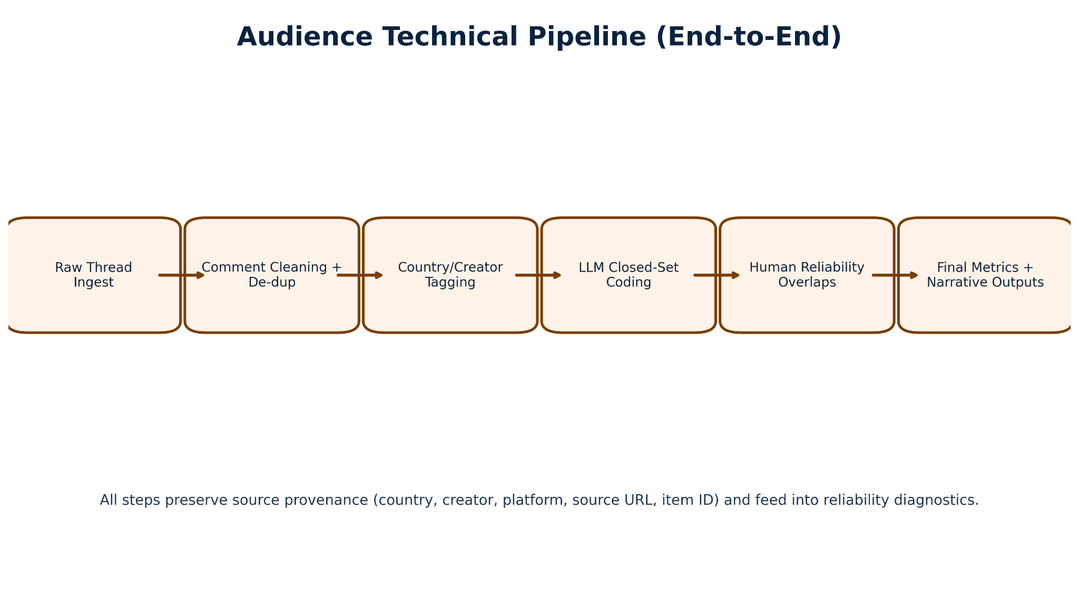

C.7 End-to-End Methodology Workflow: 1) Define country-creator sampling frame and inclusion criteria. 2) Collect raw public posts/comments and preserve source metadata. 3) Filter and deduplicate items; remove spam/non-substantive entries. 4) Standardize language variants and normalize text for coding comparability. 5) Run structured LLM coding against closed-set audience codebook labels. 6) Run human coding on validation sample with pairwise and all-coder overlap design. 7) Compute human-human and human-LLM agreement metrics on closed fields; treat open-text separately. 8) Conduct discrepancy review for boundary cases and schema consistency. 9) Finalize analytic tables/figures and document limitations, reliability interpretation, and reproducibility notes.

Appendix D. LLM Coding and Human Validation Toolkit
D.1 Label framework used in final GPT-5.5 coding: The final coding pass used closed-set labels aligned to the final Master and Intercoder Reliability schema. Content labels covered topic families, masculinity framing type, prescriptions for men, identified social problems, solution framing, communication mode, audience needs, support and justification style, sentiment toward men and women, and calls to action. Audience labels covered sentiment, emotional tone, emotional response, mention of gender norms, stance toward source content, audience need served, personal experience, sexist language, learning, attitude change, reinforcement, calls to action, information sharing, advocacy, correction behavior, and self-identification markers. These labels were selected because they directly operationalize the research questions on normative masculinity scripts, audience uptake mechanisms, and cross-country comparability while preserving coder interpretability.
D.2 Model stack: Exploratory analysis: GPT-4o-mini (OpenAI) for framing analysis, argument mining, misogyny detection, sentiment, emotion, and theme identification. Initial structured coding pass: Claude Sonnet 4.6 (Anthropic). Transcription, Gemini 2.5-Flash (Google). Embeddings, text-embedding-3-small (OpenAI). Final structured coding (all tasks re-run after systematic error review): GPT-5.5 (OpenAI). GPT-5.5 is used for all LLM coding, EDA analysis, QA, and report update reported as final findings. The re-run was triggered by identified misclassification patterns in the GPT-4o-mini outputs, particularly in misogyny type detection and multi-select theme fields. All models operated under deterministic or low-temperature settings to maximise batch consistency.
D.3 Prompt architecture: Framing prompts instructed the model to identify problem definition, causal attribution, and implied solution for each comment. Argument mining prompts instructed the model to extract the primary claim, supporting reasons, and implicit conclusion. Misogyny/sexism prompts used Glick and Fiske’s (1996) ASI dimensions as an explicit classification schema, distinguishing hostile sexism (dominance, derogation, control) from benevolent sexism (protective paternalism, idealised femininity, heterosexual intimacy framing). Theme prompts used a closed-set taxonomy defined in the codebook. Sentiment and emotion prompts used standard affect categories.
D.4 Quality assurance: LLM outputs were reviewed for hallucination, schema violations, and systematic disagreement patterns. Human validation caught sarcasm misclassification, Pidgin/Yoruba/Igbo/Sheng interpretation errors, and false positives in misogyny detection where irony was deployed. The pipeline preserved full provenance, every output is traceable to its source comment and model call.

Appendix E. Figure Appendix: Audience Analysis Visuals
Note: Content analysis figures are reported separately in the Content Analysis Report.
Appendix Figure A1. Nigeria audience corpus: comment count and orientation by creator.
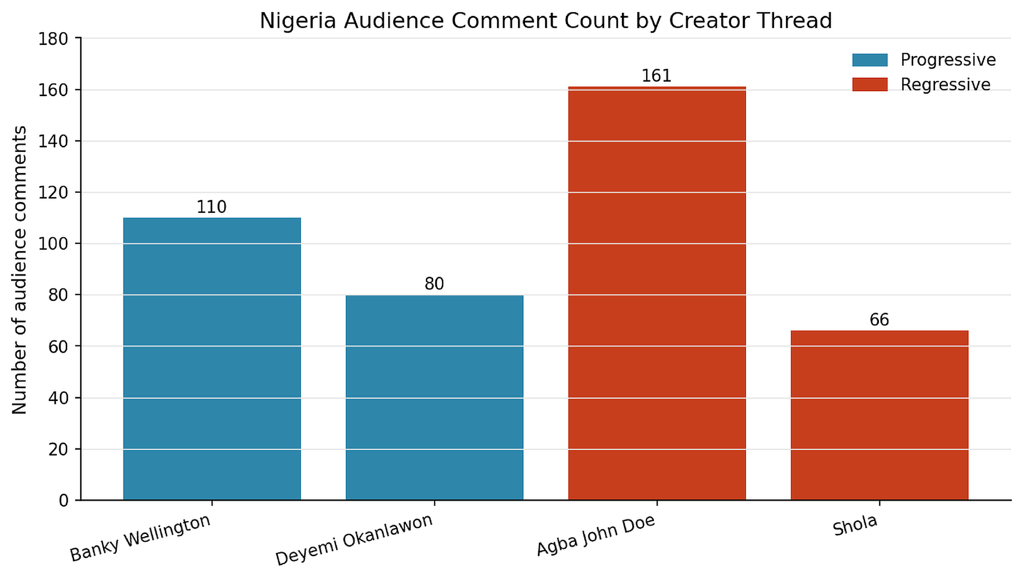

Appendix Figure A2. Kenya audience corpus: comment count and orientation by creator.
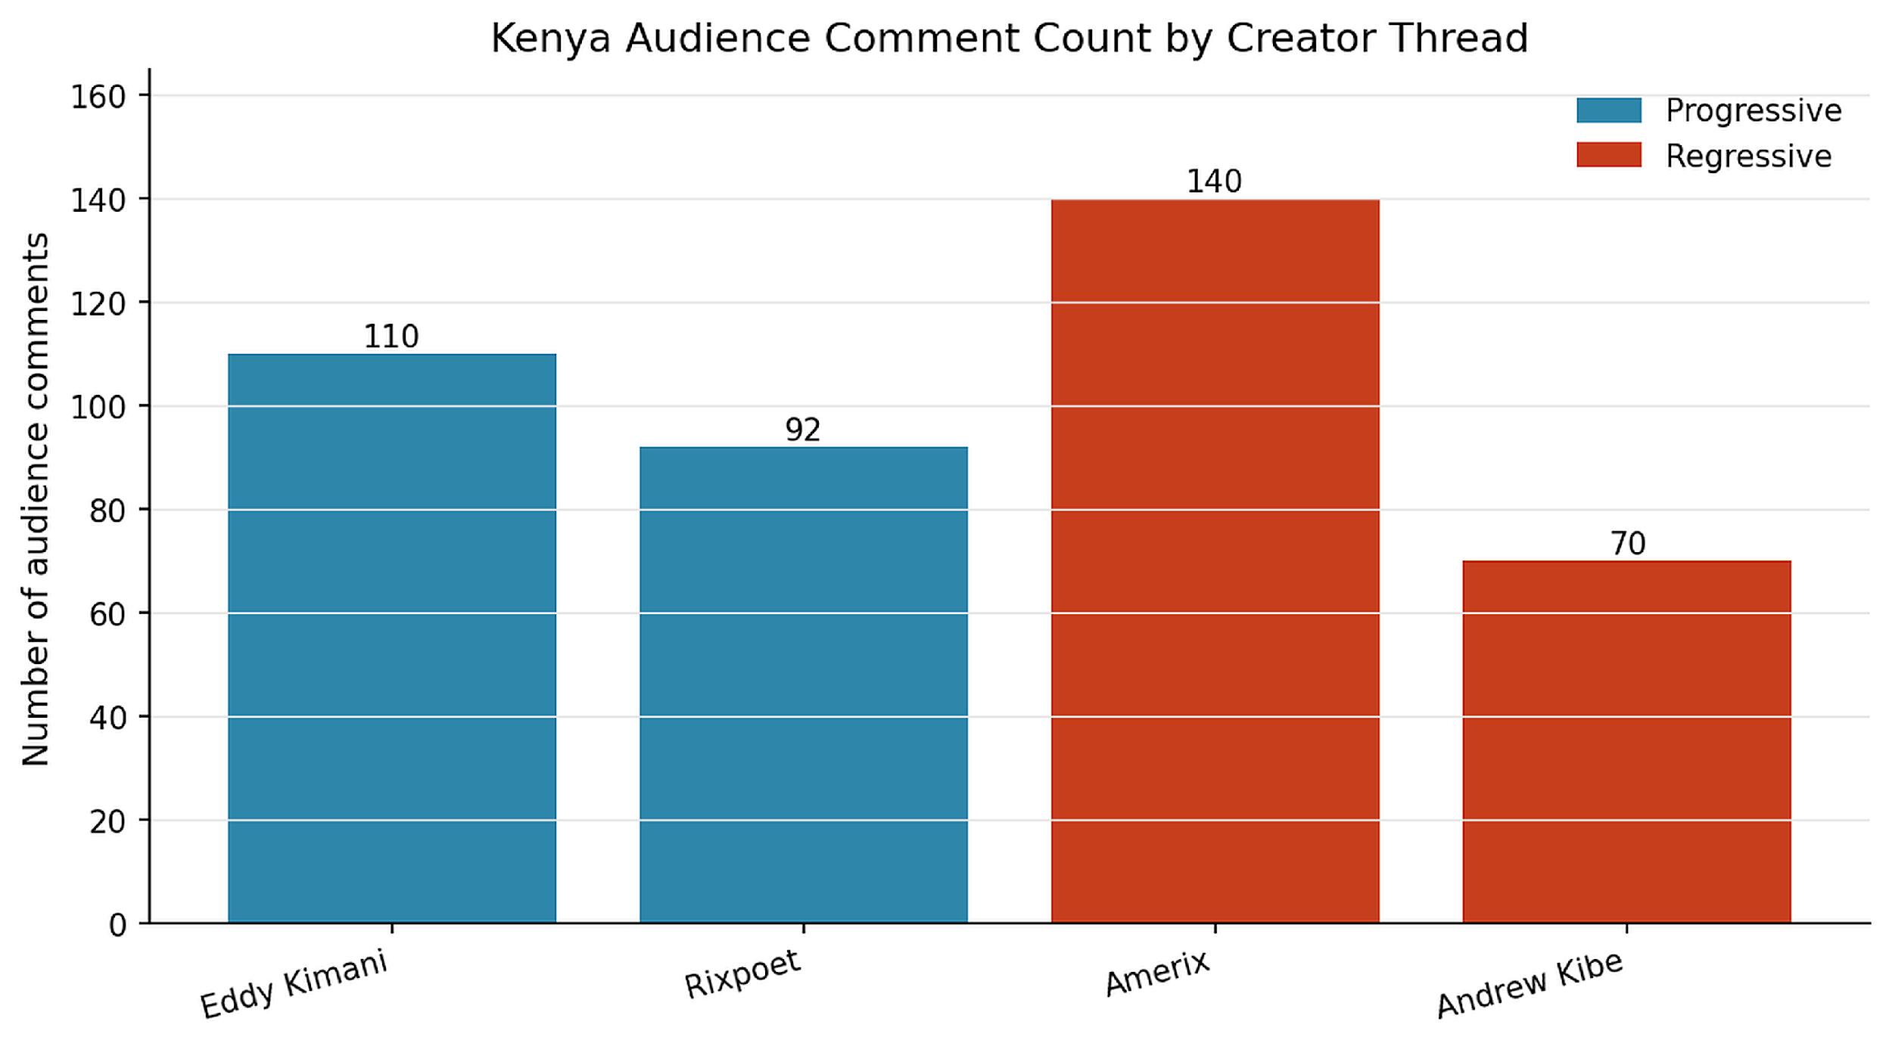

Appendix Figure A3. Audience response mechanism mix by creator: support, contest, testimony, challenge.
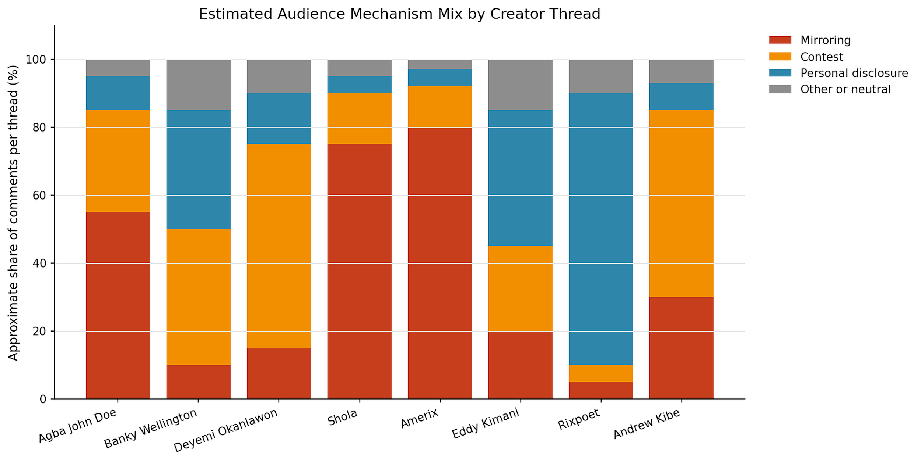
Appendix Figure A4. Sentiment distribution by country and creator/source orientation.
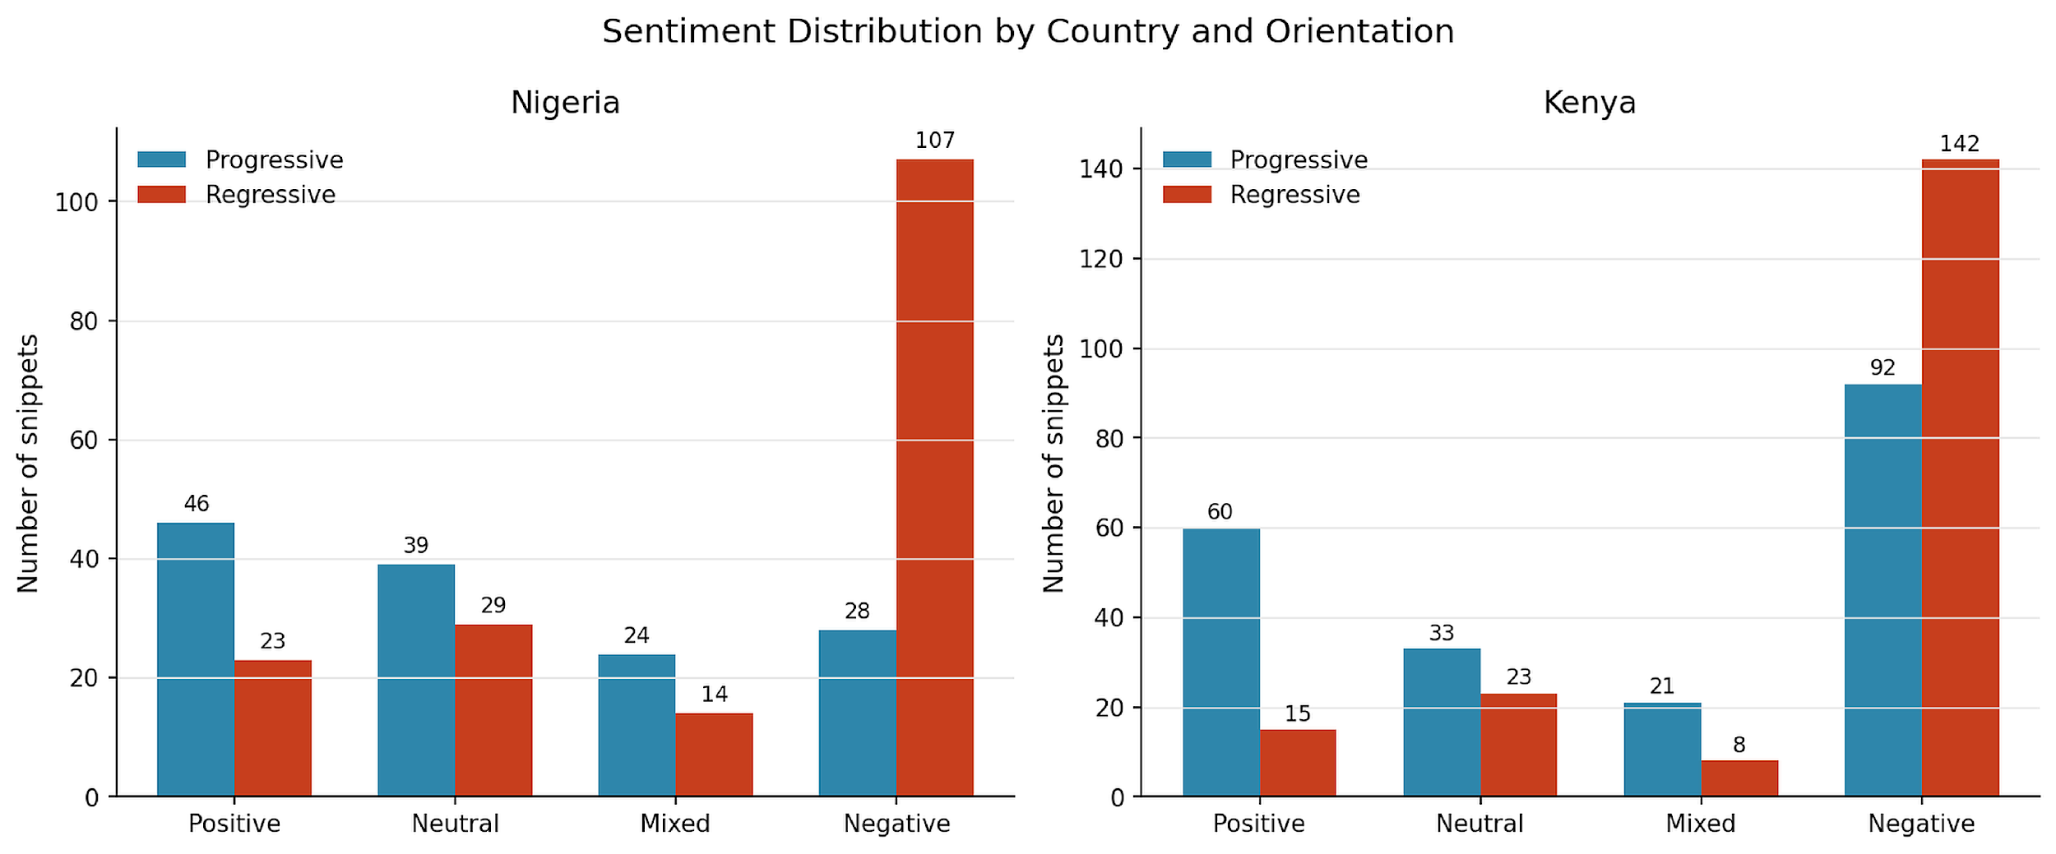

Appendix Figure A12. Project corpus overview: content snippets and audience comments by country.
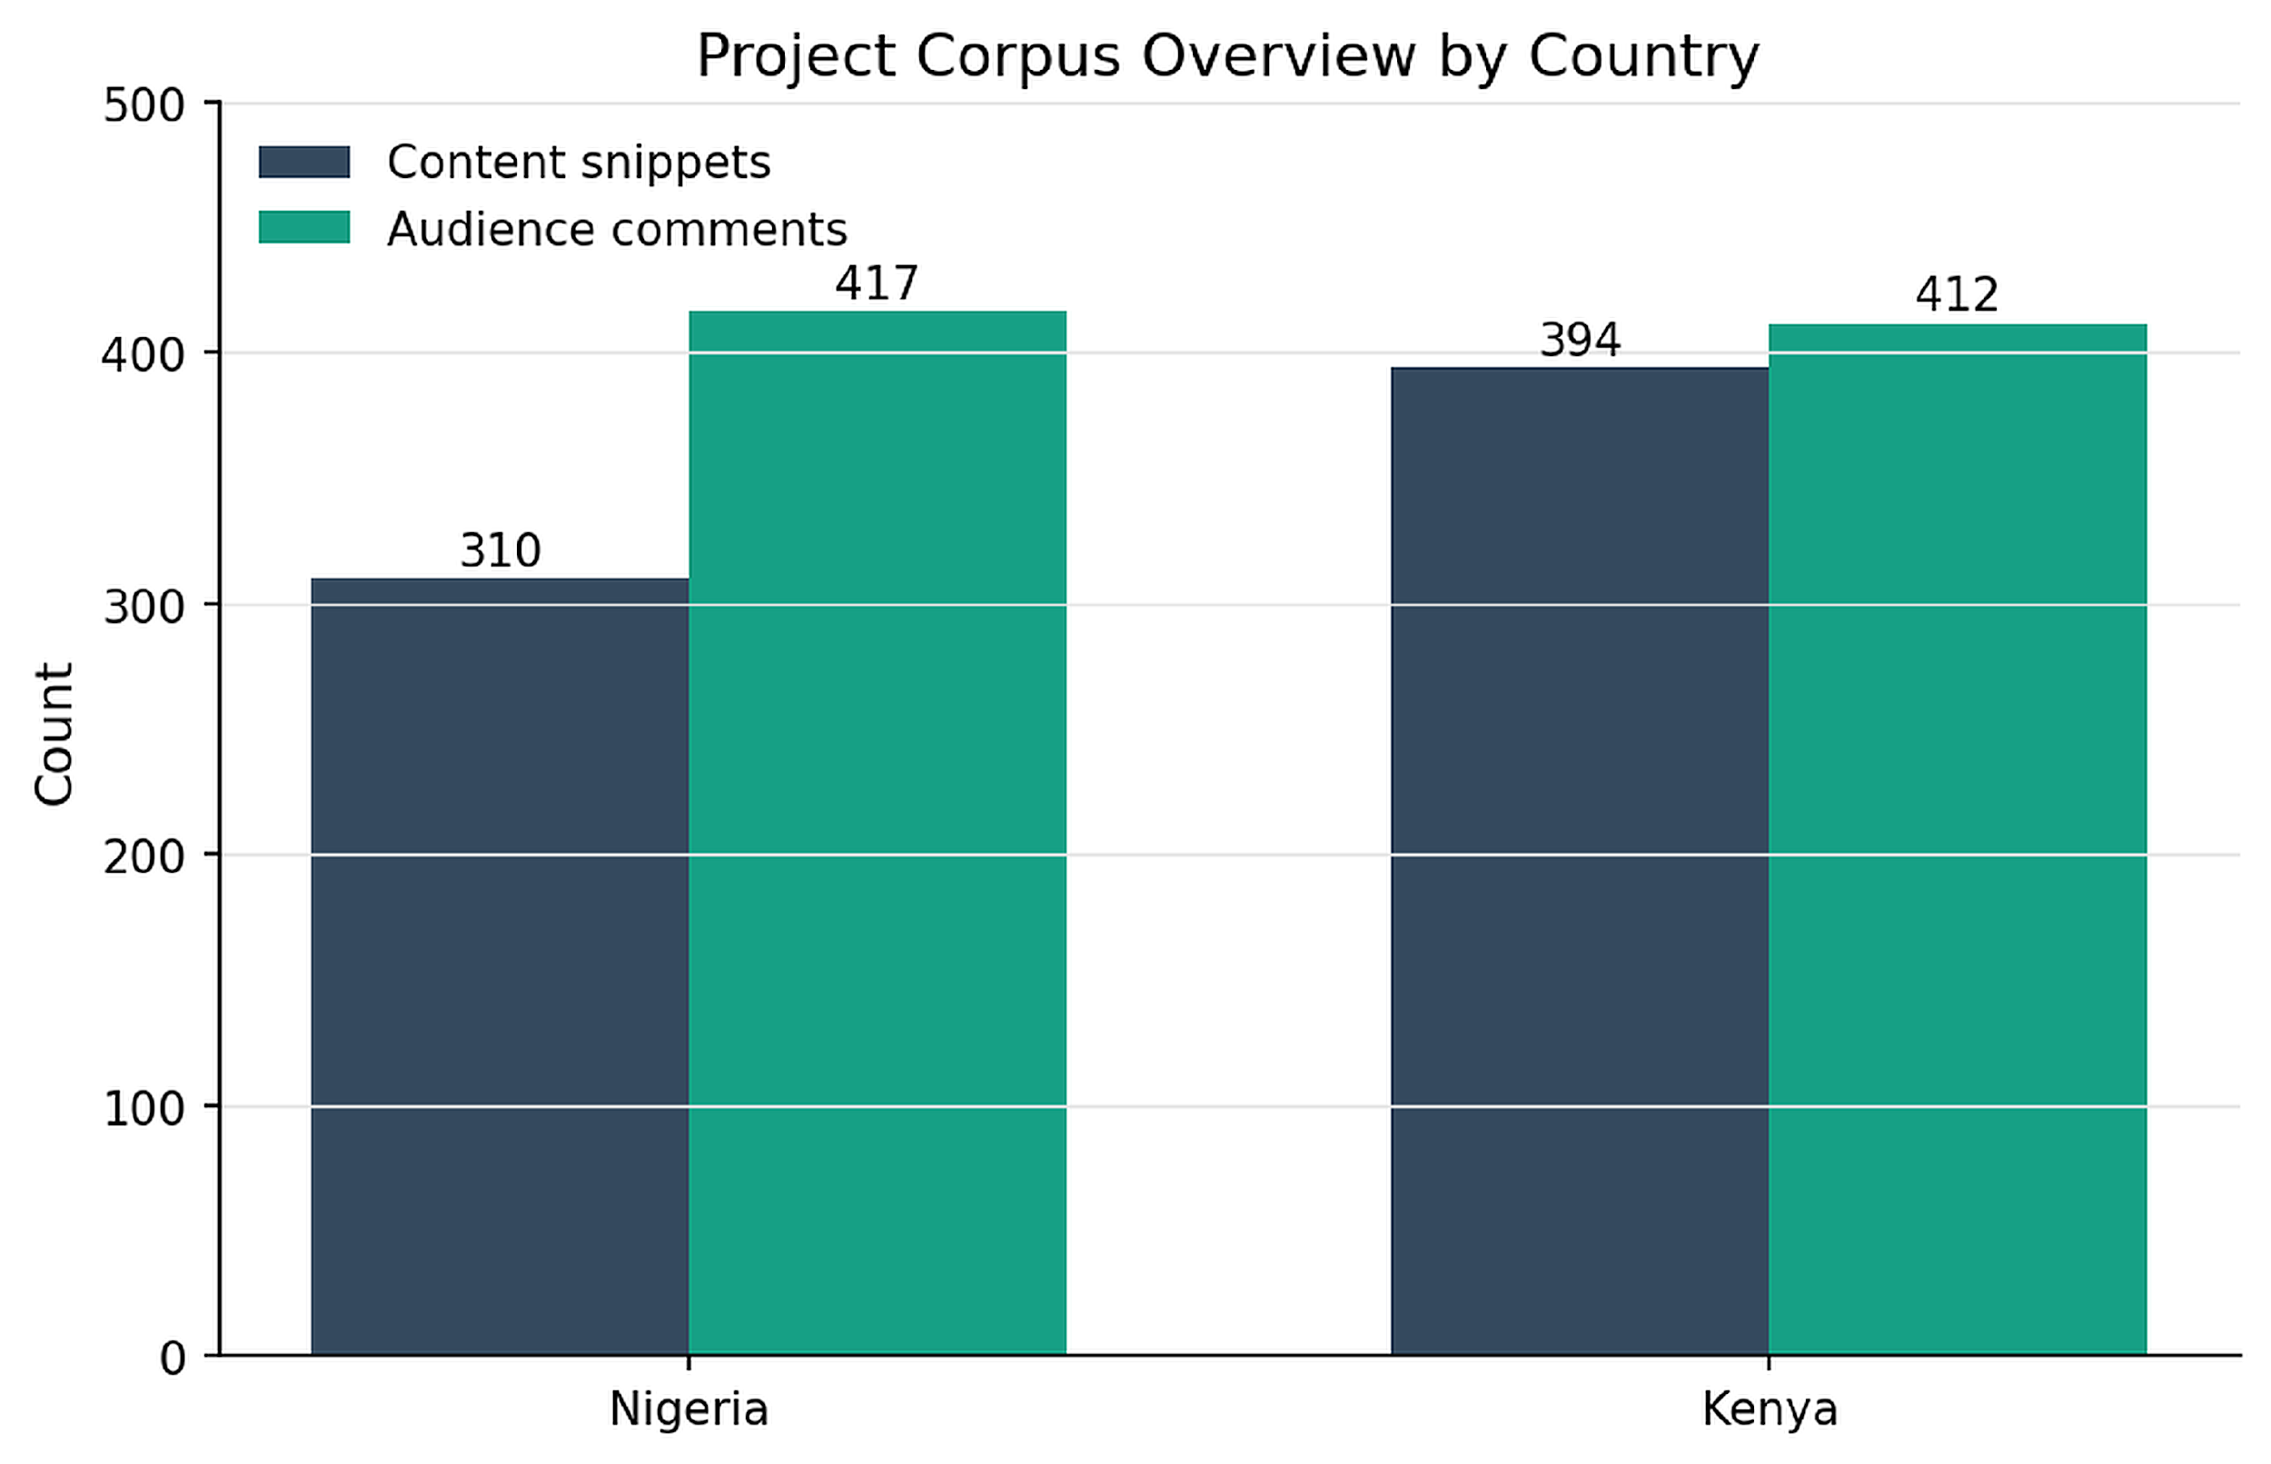

Appendix Figure A13. Combined audience corpus: comment count by country and orientation.
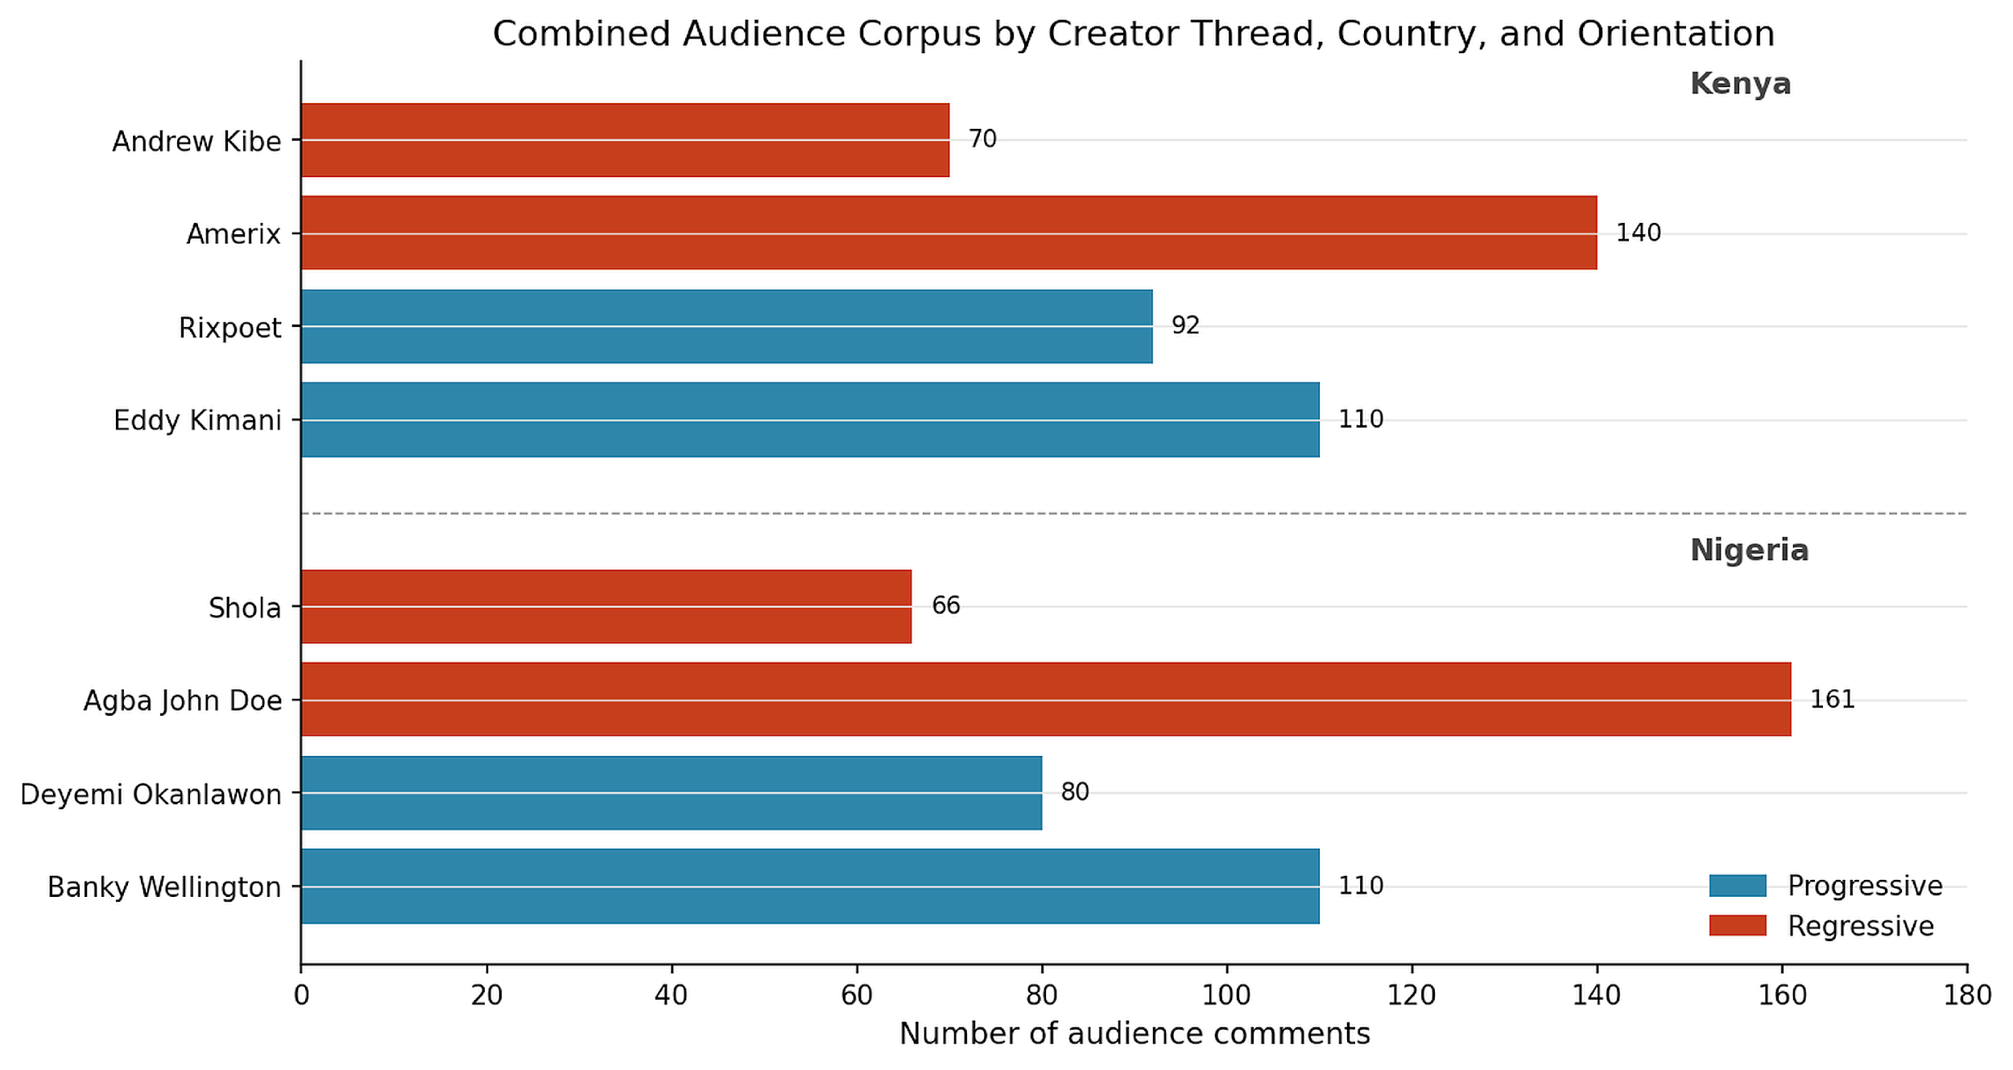

Interpretation note: Lower overall alpha is expected for complex interpretive coding with high-category decision spaces. Fields with clearer surface markers tend to reach higher agreement.

Appendix F. Evaluation Metrics
Metric definition and applicability table:
Category | Metric | Applies to | Interpretation
Reliability metric frame | Exact agreement | Closed single-choice fields | Percent exact match between coders
Reliability metric frame | Set overlap | Closed multi-select fields | Mean overlap score for multi-label fields
Reliability metric frame | Cohen kappa | Human-human closed fields | Chance-adjusted agreement for human coders
Reliability metric frame | Krippendorff alpha | Human-LLM single-choice closed fields | Krippendorff α (category-based) across the closed-field validation sample (see Table 7).
Reliability metric frame | Mean Jaccard | Human-LLM multi-select fields | Mean Jaccard (category-based) across multi-select closed fields (see Table 7).
Reliability metric frame | Precision / Recall / F1 | Human-LLM classification diagnostics | Dataset-level classification performance (see Table 8).
Metric application protocol: To prevent cross-metric misinterpretation, Appendix F distinguishes primary reporting metrics from supplementary diagnostics. Primary interpretation in this report should use the closed-field frame per track-country. Krippendorff α and mean Jaccard (category-based) are reported in Table 7 and classification metrics (single-choice micro-F1, multi-choice binary/micro-F1) are reported in Table 8; both are computed on the full closed-field validation sample by track-country.
Table F1. Metric definition and applicability guardrails
Metric family | Statistic | Primary or Supplementary | Applies to | Interpretation rule
Human-human reliability | Exact agreement (%) | Primary | Single-choice closed fields | Use as headline human consistency indicator by track-country.
Human-human reliability | Mean set overlap (%) | Primary | Multi-select closed fields | Use with exact agreement to represent partial-label concordance.
Human-LLM reliability | Krippendorff alpha (full closed-field frame) | Primary | Single-choice closed fields | Use for cross-track comparison when computed on identical field sets.
Human-LLM reliability | Mean Jaccard (full closed-field frame) | Primary | Multi-select closed fields | Use for cross-track comparison when field scope is matched.
Human-LLM diagnostics | Single-choice micro-F1 / Multi-choice binary/micro-F1 | Supplementary | All closed fields (single-choice and multi-select) | See Table 8 for dataset-level classification performance.
Mixed-metric safeguard | Cohen kappa / alpha / agreement / Jaccard / F1 | Protocol | All reliability sections | Always read each metric with its field scope, label type, and denominator definition.

This appendix lists each evaluation metric relevant to the Gates/NLC project evaluation checklist. Metrics that were calculated are listed with their values. Advanced standardized longitudinal metrics are outside the measurement scope of this study and not reported here.
Metric category | Metric | Value / Notes
Corpus | Total audience comments | 829 (Nigeria 417, Kenya 412)
Corpus | Nigeria platform distribution | 73.6% X/Twitter, 26.4% YouTube
Corpus | Kenya platform distribution | 51.0% X/Twitter, 26.7% TikTok, 22.3% YouTube
Human coding | Master item rows | 400 (200 Nigeria, 200 Kenya)
Human coding | Total coder assignments | 480 (240 per country)
Human coding | Overlap IDs (pairwise + all-coder) | 20 per country
Reliability | Human-human exact agreement (NG) | 71.0%
Reliability | Human-human set overlap (NG) | 72.5%
Reliability | Human-human exact agreement (KE) | 65.2%
Reliability | Human-human set overlap (KE) | 67.8%
Reliability | Cohen's kappa | Human-human mean kappa by track-country: Content Nigeria 0.129, Content Kenya 0.275, Audience Nigeria 0.305, Audience Kenya 0.280.
Reliability | Confusion matrices | Computed for human vs LLM on final closed fields by track-country; see the project confusion-matrix appendix output (single-choice label matrices + per-field diagnostics).
Reliability | Krippendorff α - Human-human, Content Nigeria | 0.147 (mean; range -0.087 to 0.296; 18 fields)
Reliability | Krippendorff α - Human-human, Content Kenya | 0.274 (mean; range -0.121 to 0.721; 18 fields)
Reliability | Krippendorff α - Human-human, Audience Nigeria | 0.252 (mean; range -0.204 to 0.840; 17 fields)
Reliability | Krippendorff α - Human-human, Audience Kenya | 0.263 (mean; range -0.106 to 0.625; 17 fields)
Reliability | Krippendorff α - Human-LLM, Content Nigeria (category-based) | 0.567
Reliability | Krippendorff α - Human-LLM, Content Kenya (category-based) | 0.566
Reliability | Krippendorff α - Human-LLM, Audience Nigeria (category-based) | 0.754
Reliability | Krippendorff α - Human-LLM, Audience Kenya (category-based) | 0.680
Reliability | Mean Jaccard - Human-LLM, Content Nigeria (category-based) | 0.558
Reliability | Mean Jaccard - Human-LLM, Content Kenya (category-based) | 0.581
Reliability | Mean Jaccard - Human-LLM, Audience Nigeria (category-based) | 0.574
Reliability | Mean Jaccard - Human-LLM, Audience Kenya (category-based) | 0.515
Classification | Single-choice micro-F1 - Content Nigeria | 0.639
Classification | Single-choice micro-F1 - Content Kenya | 0.631
Classification | Single-choice micro-F1 - Audience Nigeria | 0.924
Classification | Single-choice micro-F1 - Audience Kenya | 0.896
Classification | Multi-choice binary/micro-F1 - Content Nigeria | 0.716
Classification | Multi-choice binary/micro-F1 - Content Kenya | 0.735
Classification | Multi-choice binary/micro-F1 - Audience Nigeria | 0.729
Classification | Multi-choice binary/micro-F1 - Audience Kenya | 0.680
Classification | Macro F1 (superseded) - Nigeria Content | 0.326
Classification | Macro F1 (superseded) - Kenya Content | 0.373
Classification | Macro F1 (superseded) - Audience Nigeria | 0.598
Classification | Macro F1 (superseded) - Audience Kenya | 0.578
Classification | Category micro-F1 - Content Nigeria | 0.716
Classification | Category micro-F1 - Content Kenya | 0.735
Classification | Category micro-F1 - Audience Nigeria | 0.729
Classification | Category micro-F1 - Audience Kenya | 0.680

Note on engagement metrics: Post-level source content engagement metrics are reported in Section 3.4 with pattern-level observations within the measurement scope of this study.
Model-use audit trail: GPT-4o-mini and Claude Sonnet 4.6 outputs are preserved in the project repository for reference. All results reported in this document are based on the GPT-5.5 re-run. Appendix D contains the full model-stack documentation and prompt architecture.

Appendix G. Terms and Definitions
Term | Definition
LLM | Large language model. In this report, GPT-5.5 was used for LLM coding, EDA analysis, QA, and report update.
EDA | Exploratory data analysis. A discovery layer used to identify patterns in the full dataset.
Audience reception | The interpretation, affect, stance, and social action visible in audience comments.
Set overlap | A partial-credit agreement score used when a field can have multiple labels.
Gold standard | A final adjudicated dataset that would require manual resolution of disagreement rows. The present report preserves disagreement flags rather than inventing consensus.

Hegemonic masculinity (Connell and Messerschmidt 2005): the dominant cultural ideal of manhood that others are measured against, a relational configuration of practice, contested in specific social contexts. Hostile sexism (Glick and Fiske 1996): antipathy, dominance-seeking, and derogation directed at women who challenge male authority. Benevolent sexism (Glick and Fiske 1996): seemingly positive but paternalistic attitudes that cast women as weak or in need of male protection. Discourse analysis: analysis of how language constructs subject positions, naturalises social arrangements, and interpellates audiences into particular stances. Purposive sampling: selection of cases based on their analytic relevance to the research question, not random representativeness.

Appendix H. Research-Grade Reliability Visuals (Supplementary)
Appendix Figure RG1. Human-human exact agreement heatmap by track and country.
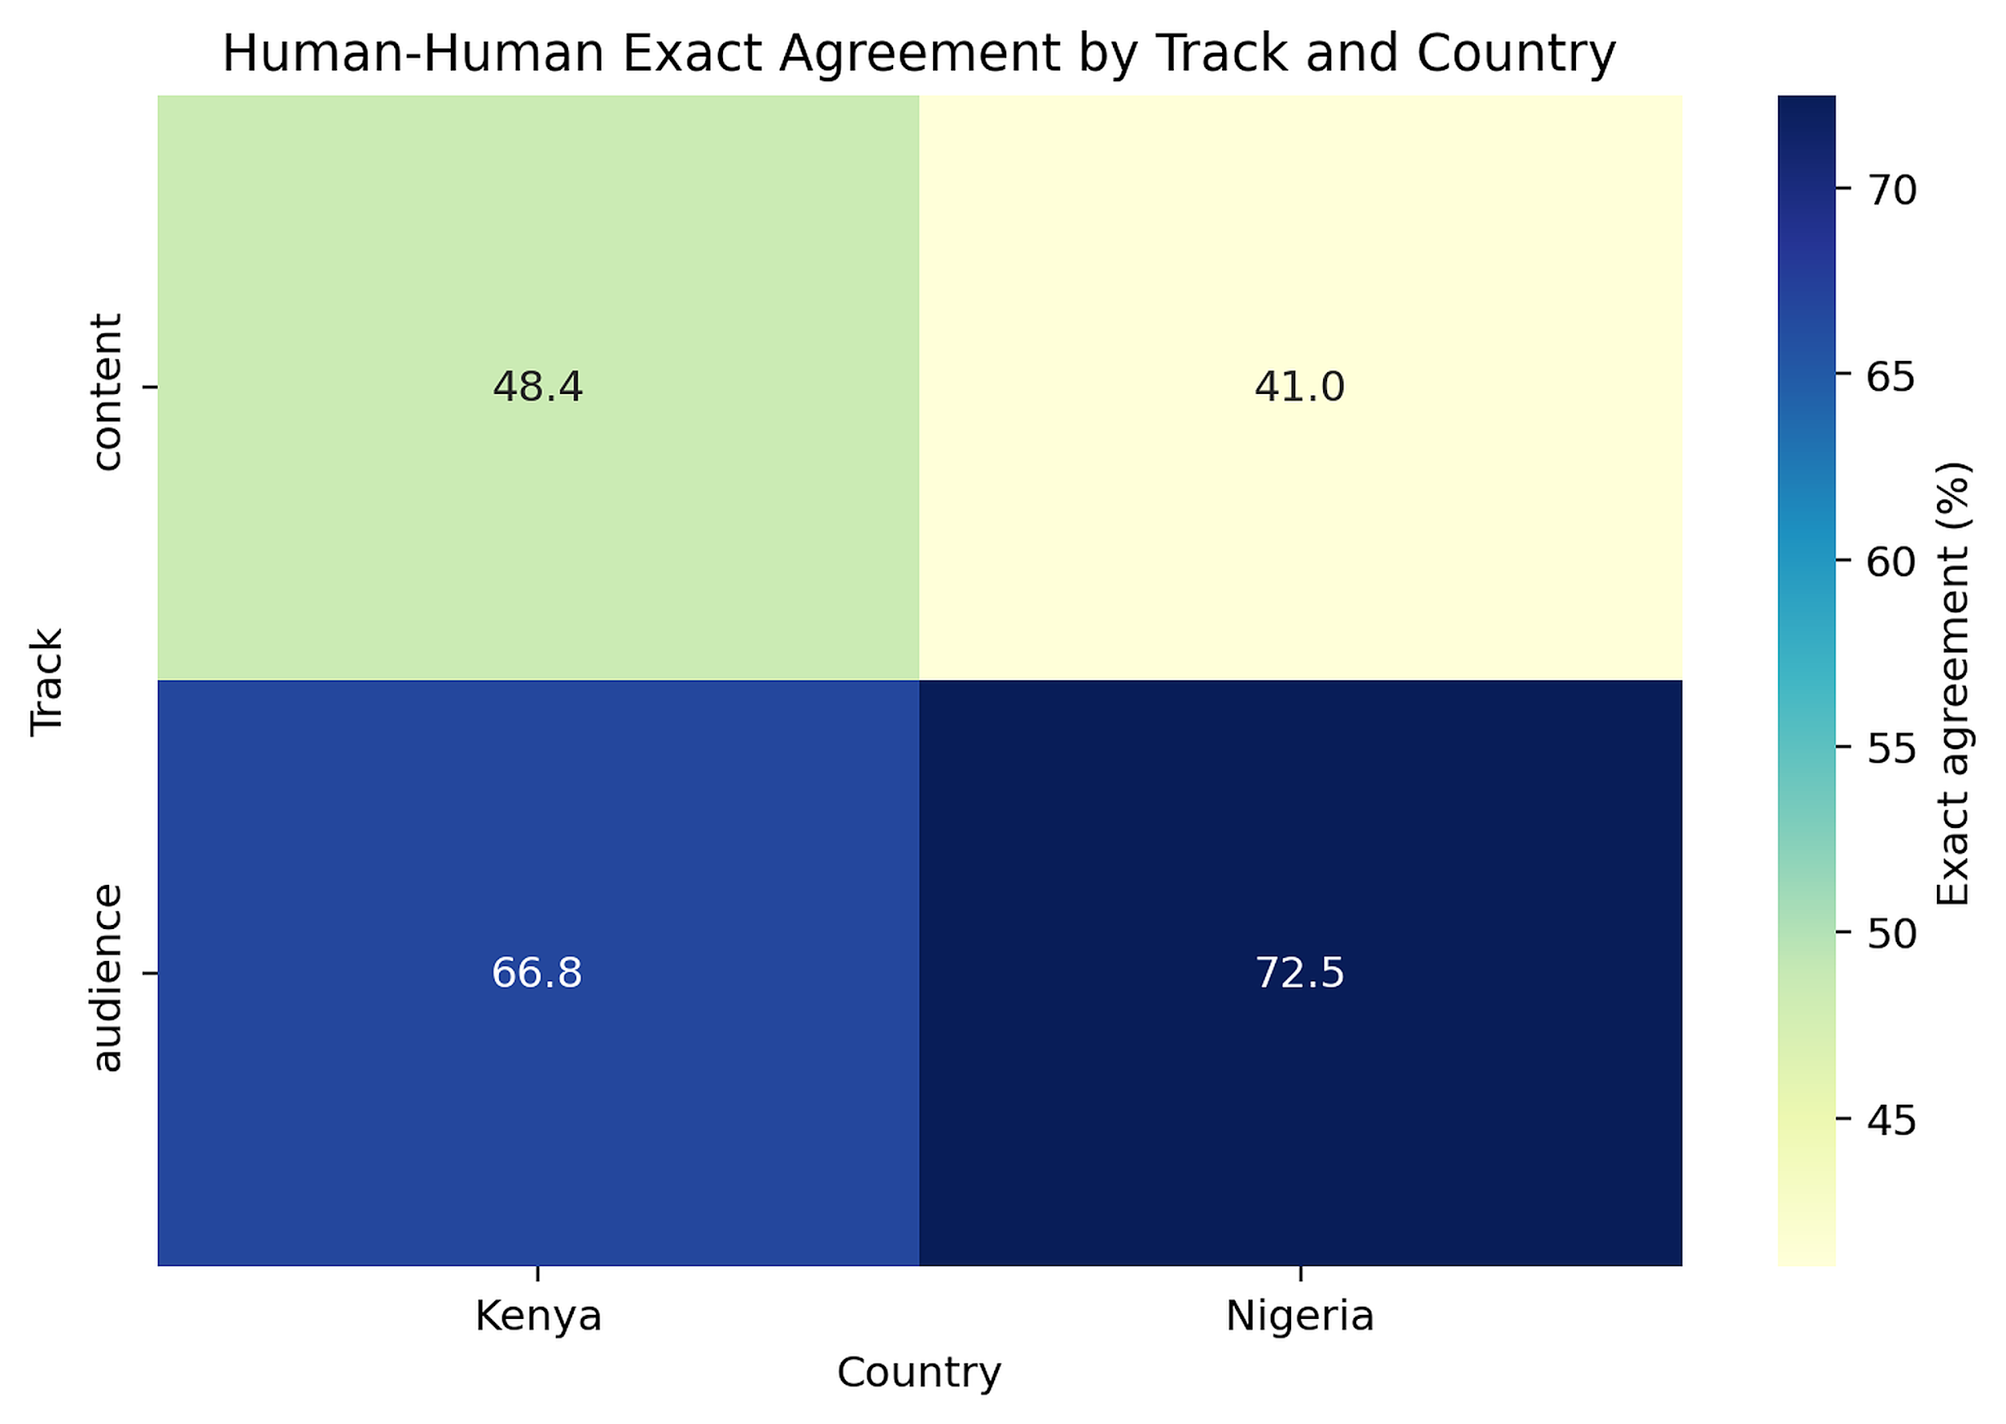

Appendix Figure RG2. Human-human mean Krippendorff alpha heatmap by track and country.
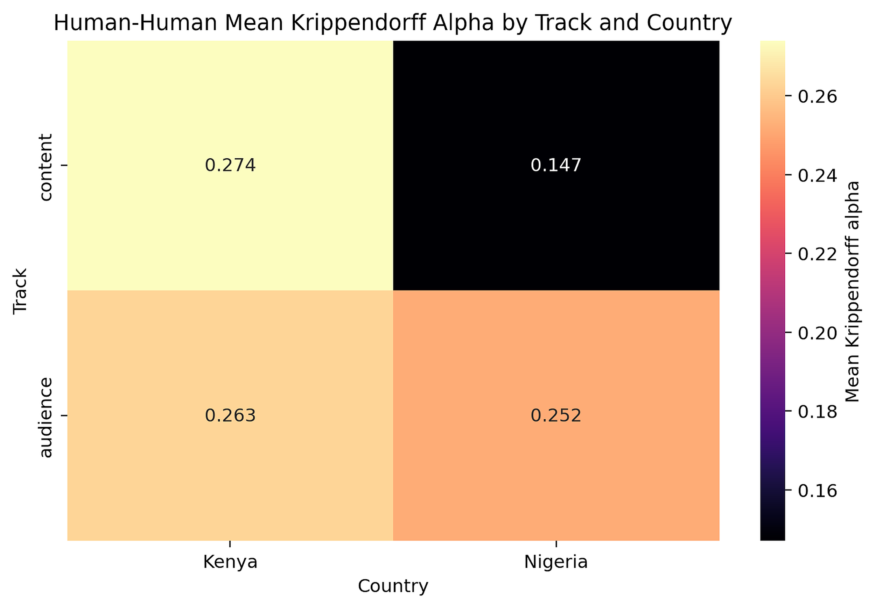

Appendix Figure RG3. Human-human exact agreement share by track (pie chart).
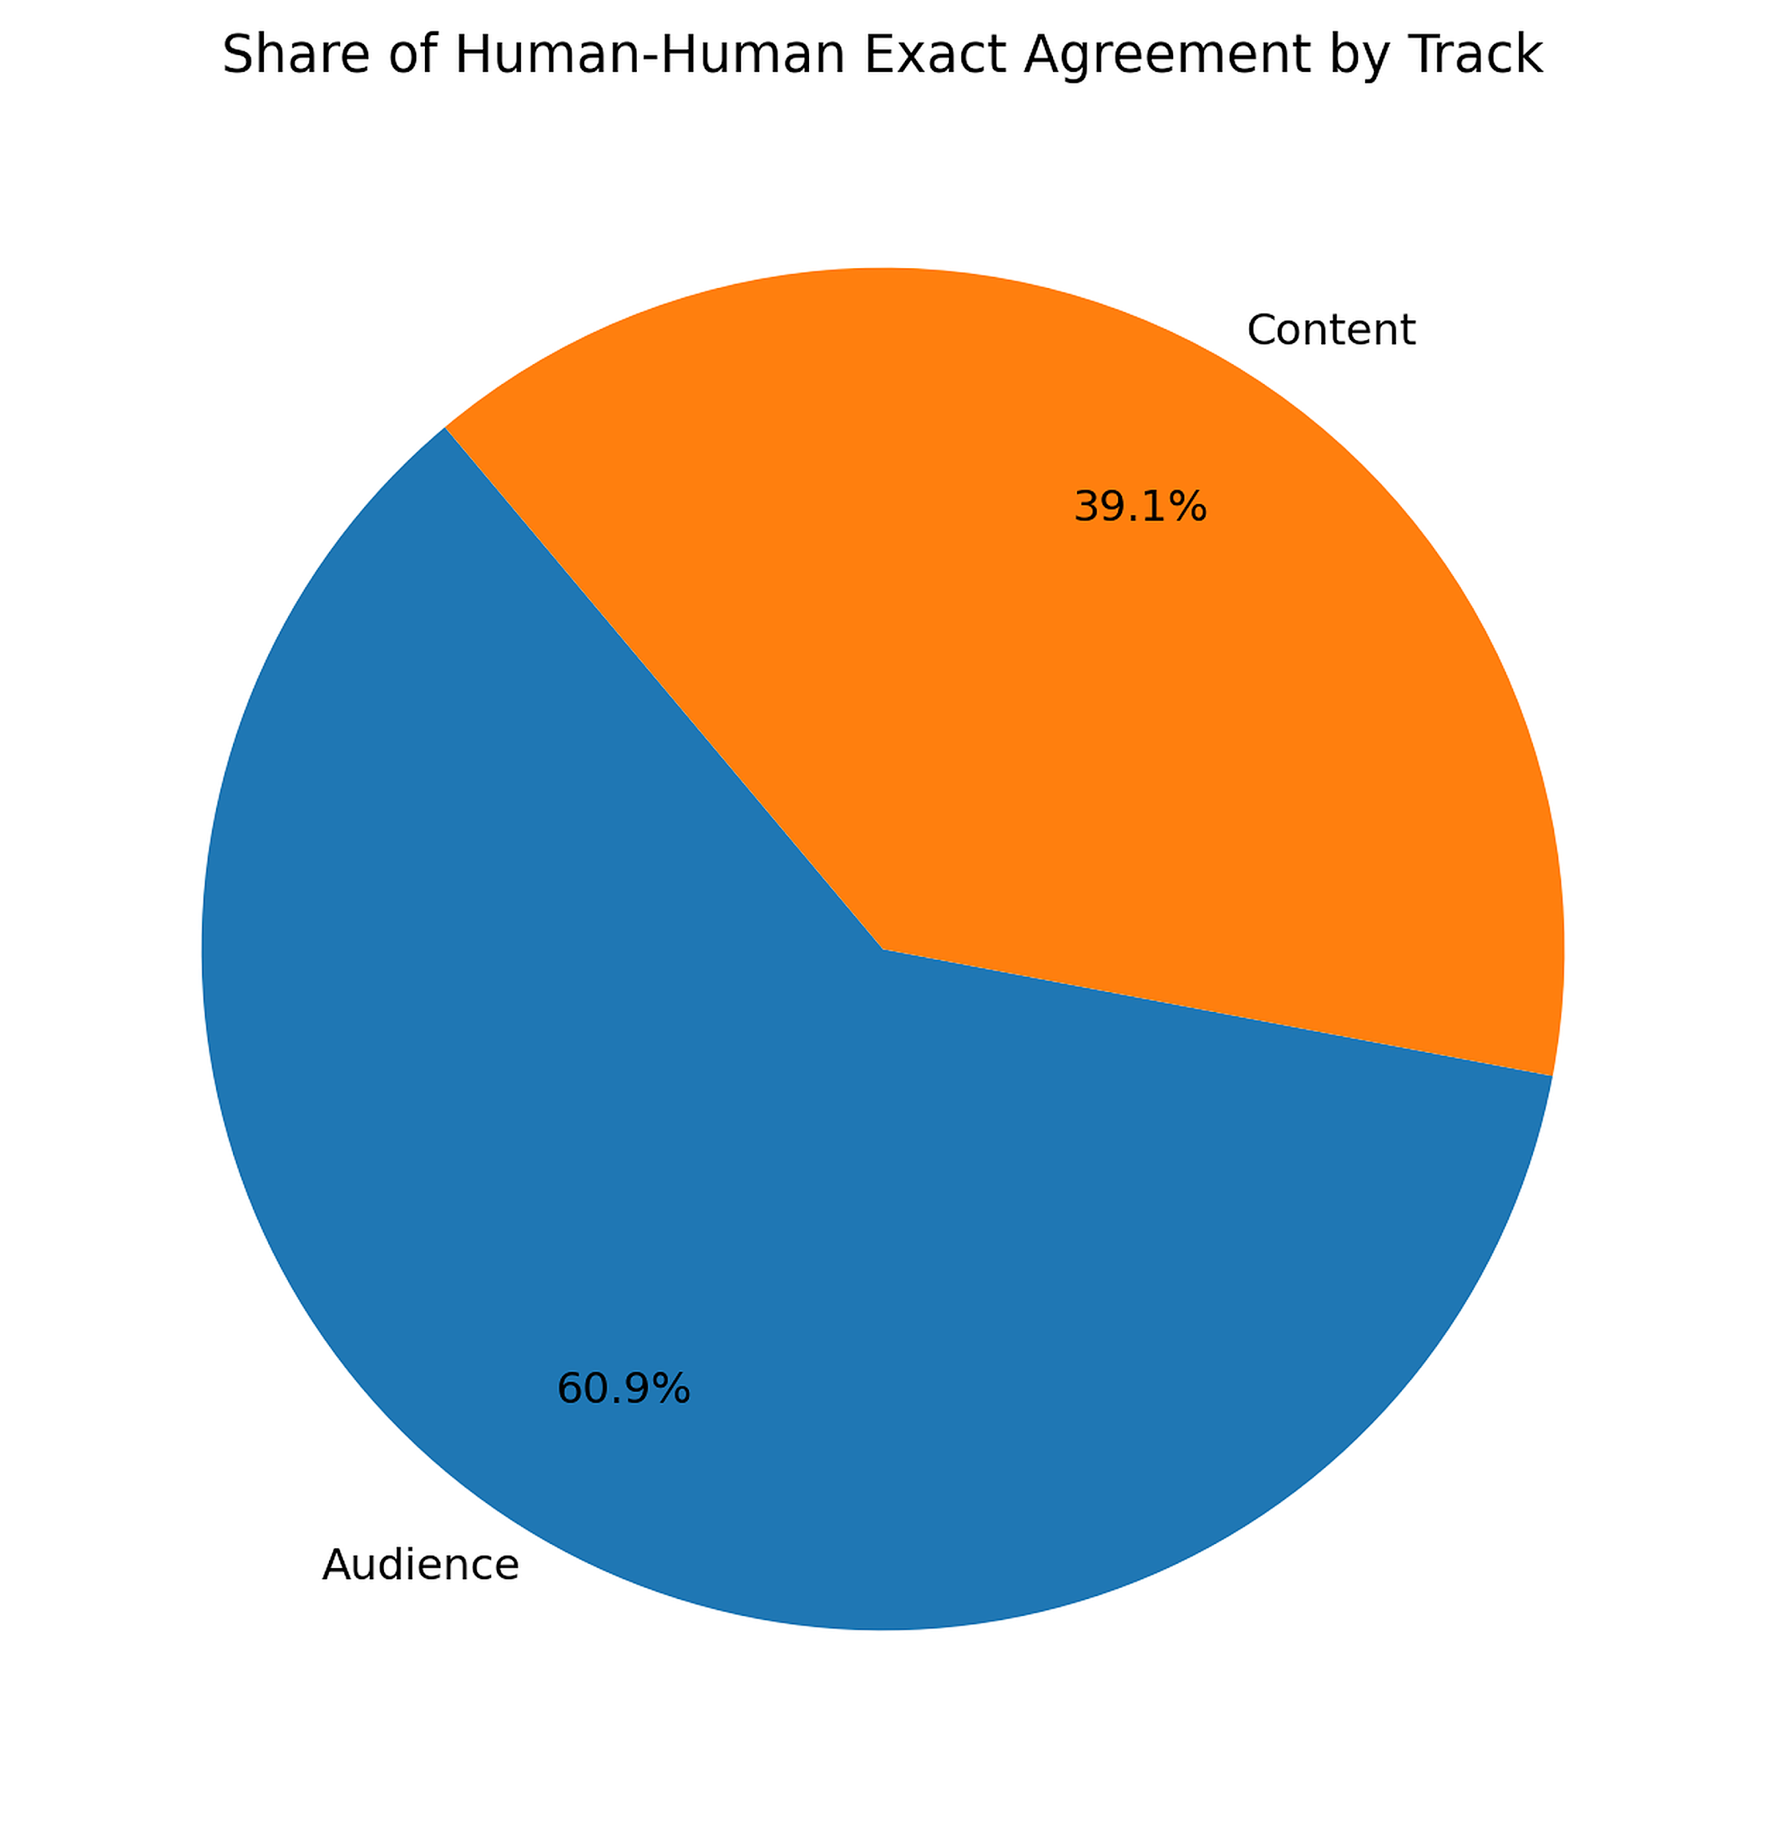

Appendix Figure RG4. Human-LLM exact agreement share by track (pie chart).
